

Network Administration
Assessment 2: Set Exercises
Module Coordinator: Ian

Date of submission: 24/04/2024
Number of words: 1,526

Description of task and work environment:
The task set is to complete a series of network administration tasks, ensuring the network configuration is correct so that communication requirements are fulfilled, and nodes and clients interact securely. (Cook, 2022)
This project uses virtual technology with Oracle VirtualBox to run three virtual machines. These are Kali Linux, Windows 10, and Metasploitable 2. They are part of a GNS3 Virtual Machine network for network simulation and testing. The project also involves setting up a Cisco Router & Switch in GNS3, to increase network security with DHCP Snooping & DAI. (Cook, 2022)
The main goal is to update the IP network to a Class B network with 512 subnet addresses, showing the ability to manage and set up network settings to meet specific needs. The work environment includes physical and virtual parts, using a home desktop PC as the main workstation. Tools like Wireshark and command-line interfaces are used for network analysis and setup. The virtual machines have software for network analysis, exploitation, and management. (Cook, 2022)
This demonstrates the flexibility of virtualization in network administration tasks. The project also involves configuring network protocols, securing SSH services, and testing network functionality. (Cook, 2022)

Catalogue:
Home Desktop PC
- Command line
- Wireshark
Kali Linux Virtual Machine w/ VirtualBox
- Dsniff - Arpspoof
- Ettercap
- Terminal
- Gedit
- Wireshark
Windows 10 Virtual Machine w/ Virtual Box
- Command Line
- PowerShell
- PuTTy
- Wireshark
Metasploitable 2
- phpMyAdmin
- Mutilldae – Exploitable webserver
Vulnweb
- Testphp site
GNS3 App/Virtual Machine
- Cisco IOSvL2 Switch
- Cisco IOSv Router
- Kali VM
- Windows VM
Wireshark
- On my desktop
- Kali VM
- Windows VM

Screenshots and annotations:

Implementing Wi-Fi protocols (Cook, 2022)

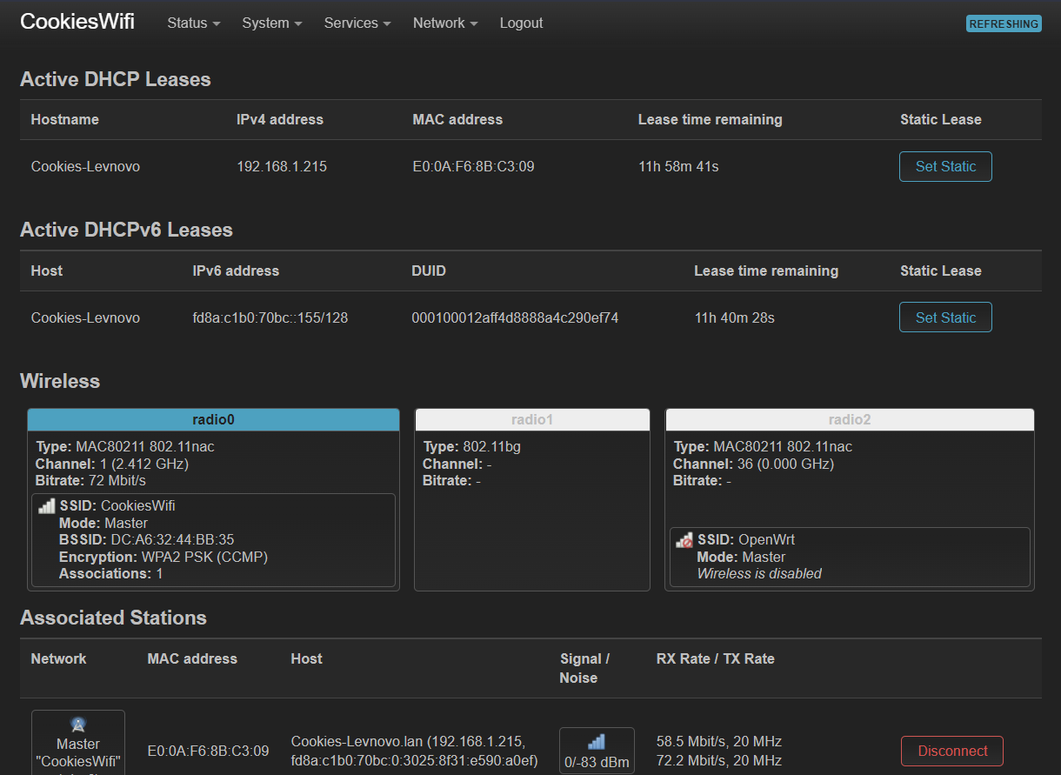
CookiesWiFi was created using 802.11ac Wi-Fi protocol and secured using WPA2 encryption and a password. (Intel, 2021) (Cook, 2022)
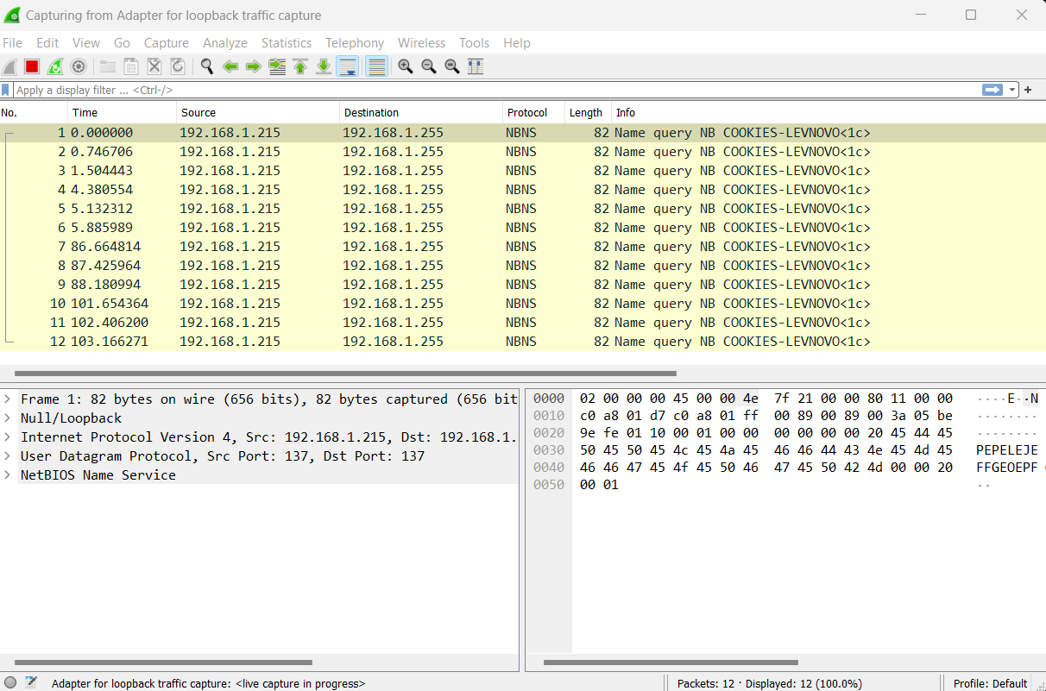
This screenshot shows the NBNS protocol which is the NetBIOS Name Service (NBNS). “NBNS serves much the same purpose as DNS does: translate human-readable names to IP addresses (e.g. www.wireshark.org to 65.208.228.223). (As NetBIOS can run on top of several different network protocols (e.g. IP, IPX, ...) and NBNS can only supply IPv4 addresses; NBNS doesn't support IPv6.” (Wireshark Wiki, 2020)

2: Reviewing network activity using Wireshark and built-in graphs
Used Wireshark to make observations and review network activity throughout each task so you can monitor and capture packets like ARPs, NBNS, TCP, DNS, HTTP etc. (Cook, 2022)
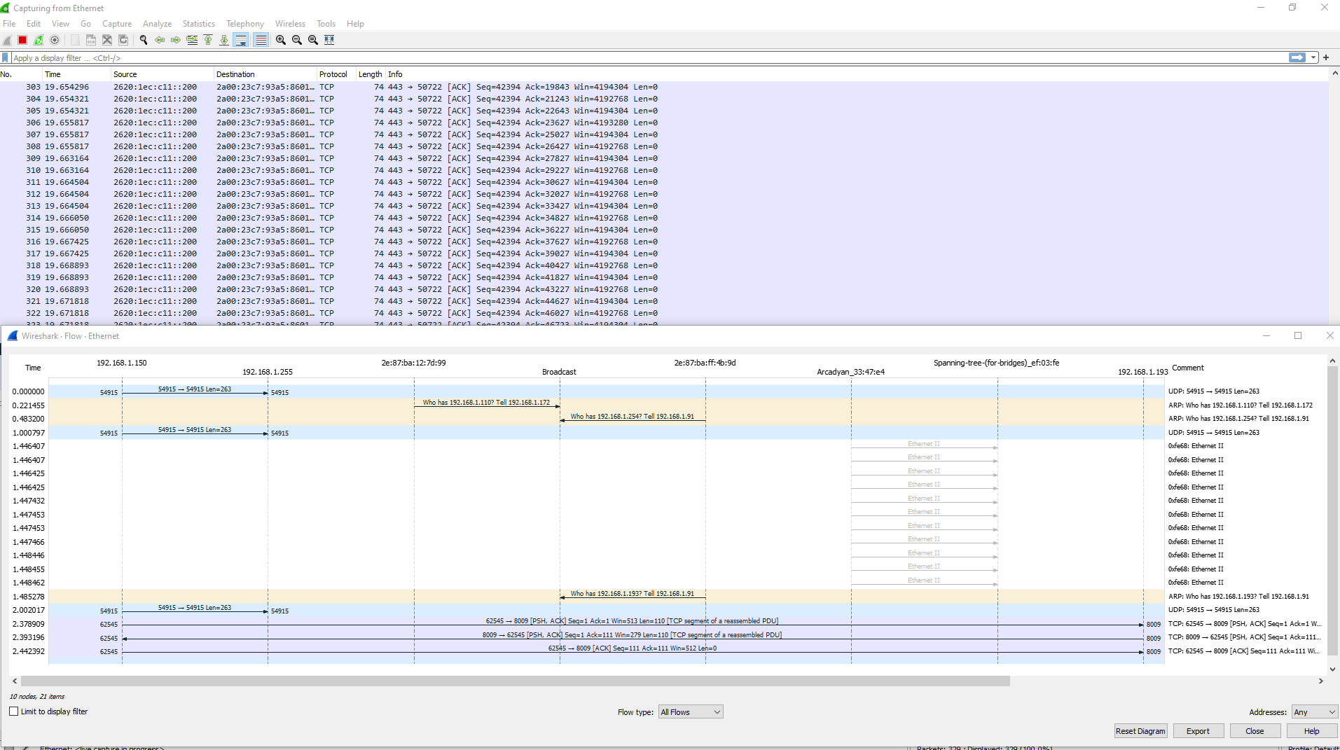
Wireshark is useful for reviewing activity as it has loads of tools that can be used to view the statistics of network traffic by using useful graphs and giving your loads of information, being able to filter data for specific protocols and enabling deep inspection on the protocols and packets. (Cook, 2022)

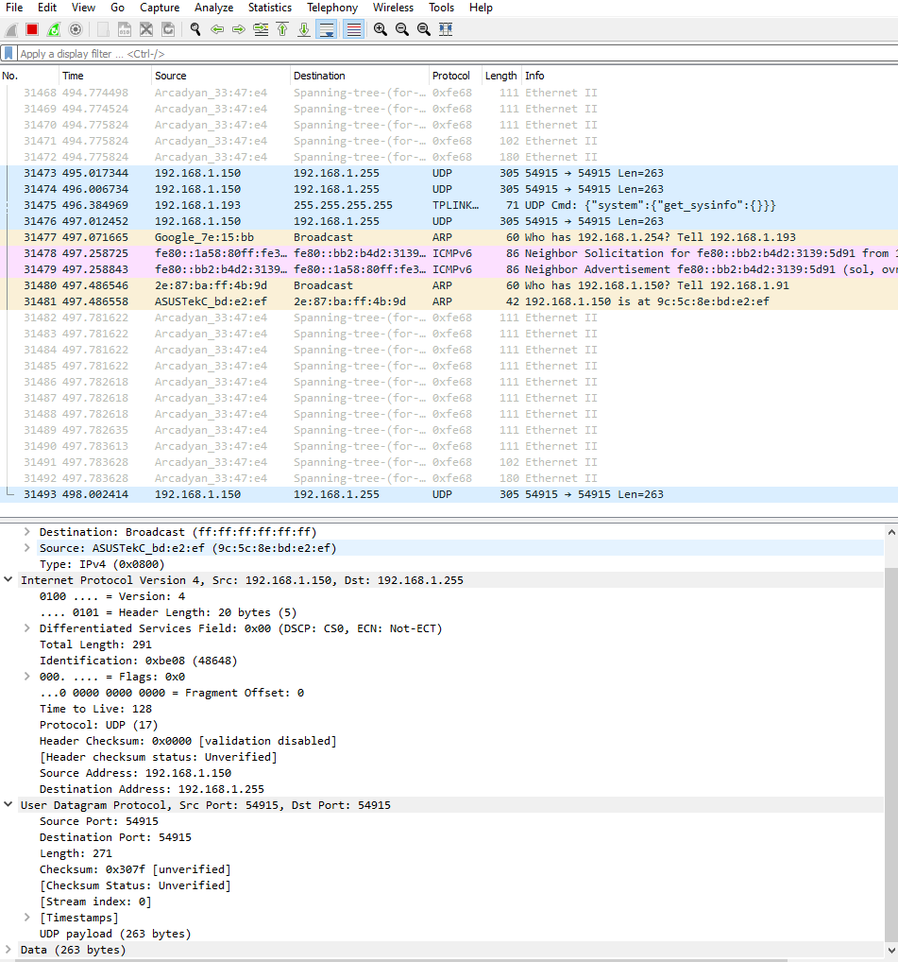

Adding mitigation to ARP Poison Attack via DHCP Snooping and Dynamic ARP Inspection:
To mitigate an ARP poison attack, I set up a GNS3 server VM, made a Cisco-based network in the application, and set up DHCP on the CiscoIOSv Router for both the Kali VM and Windows VM could send network traffic to each other. (Cook, 2022)
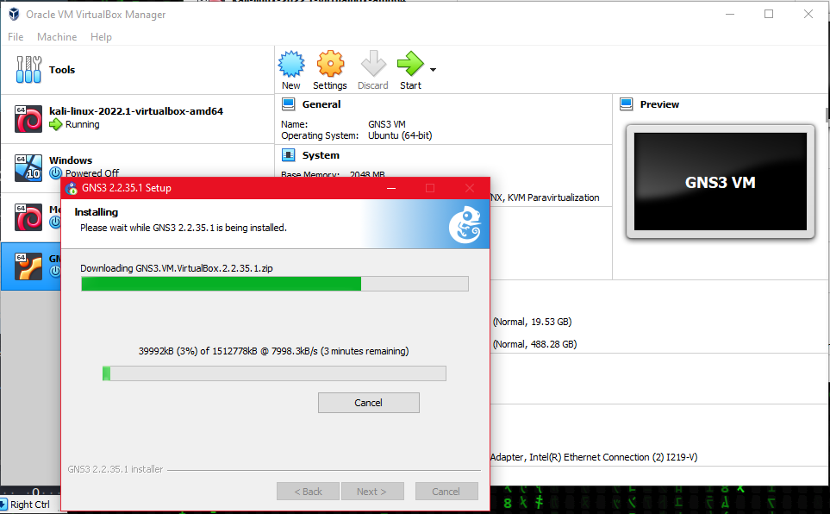
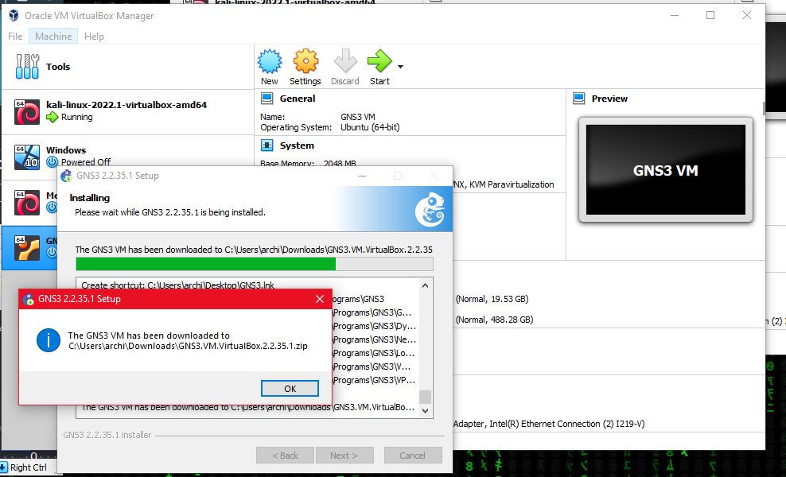
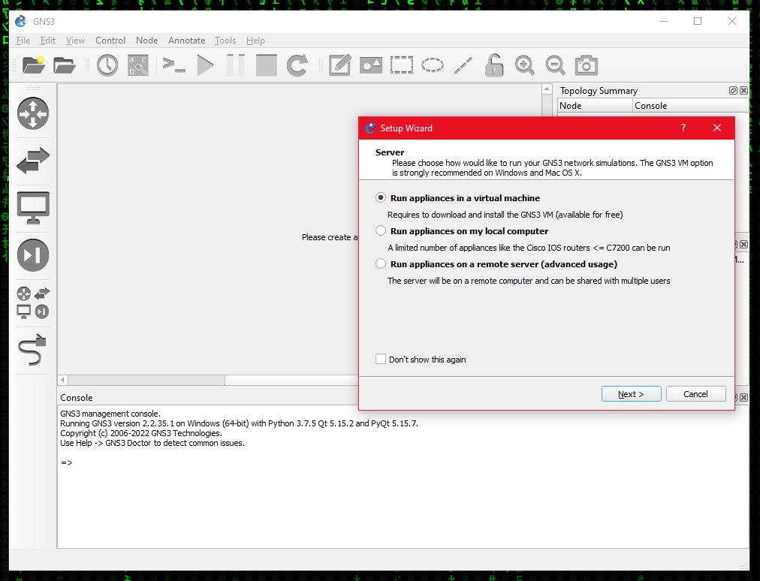
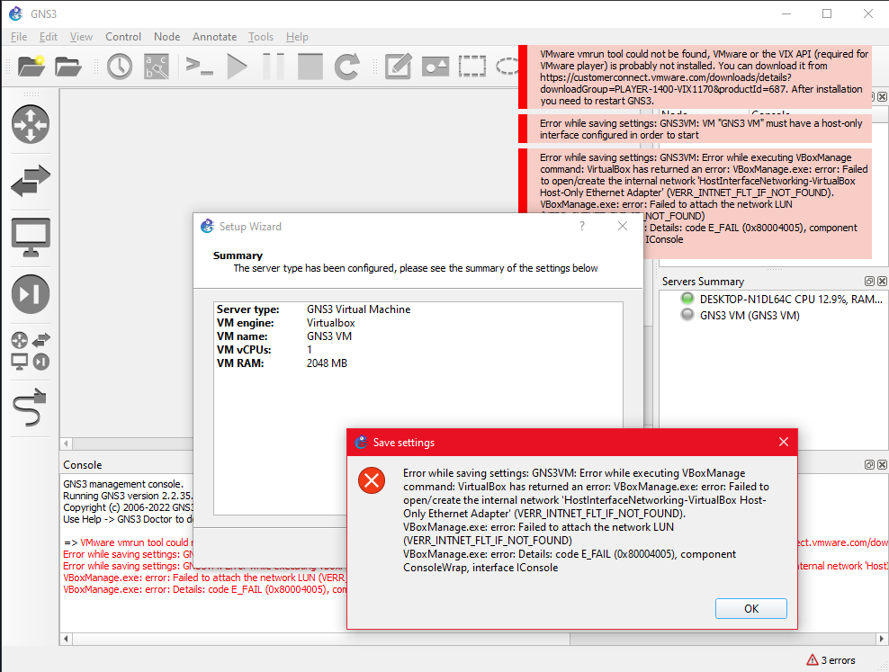
At first, it would not connect, but I disabled and re-enabled the Host-Only adapter in Device manager, deleted it, restarted my pc, and reinstalled GNS3. Then it worked. (Cook, 2022)
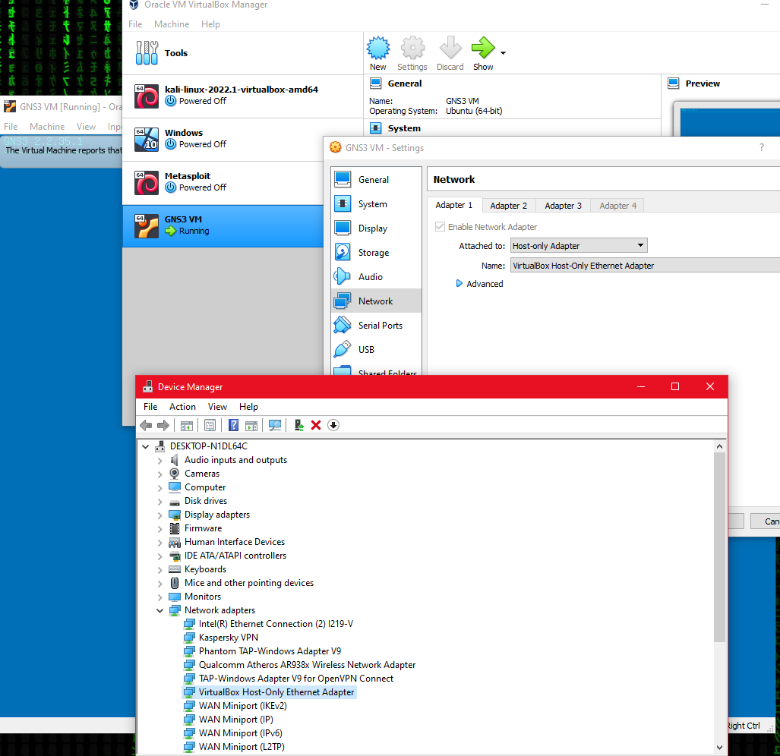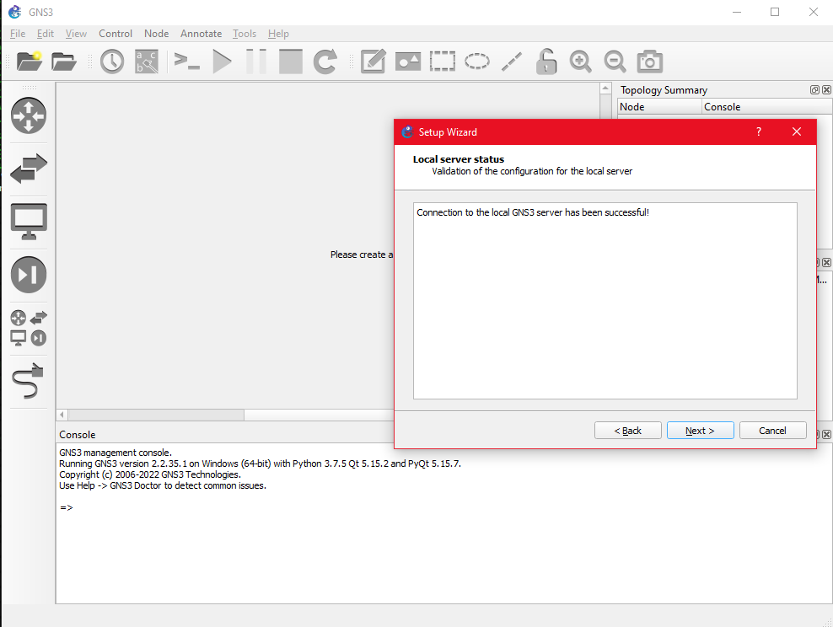
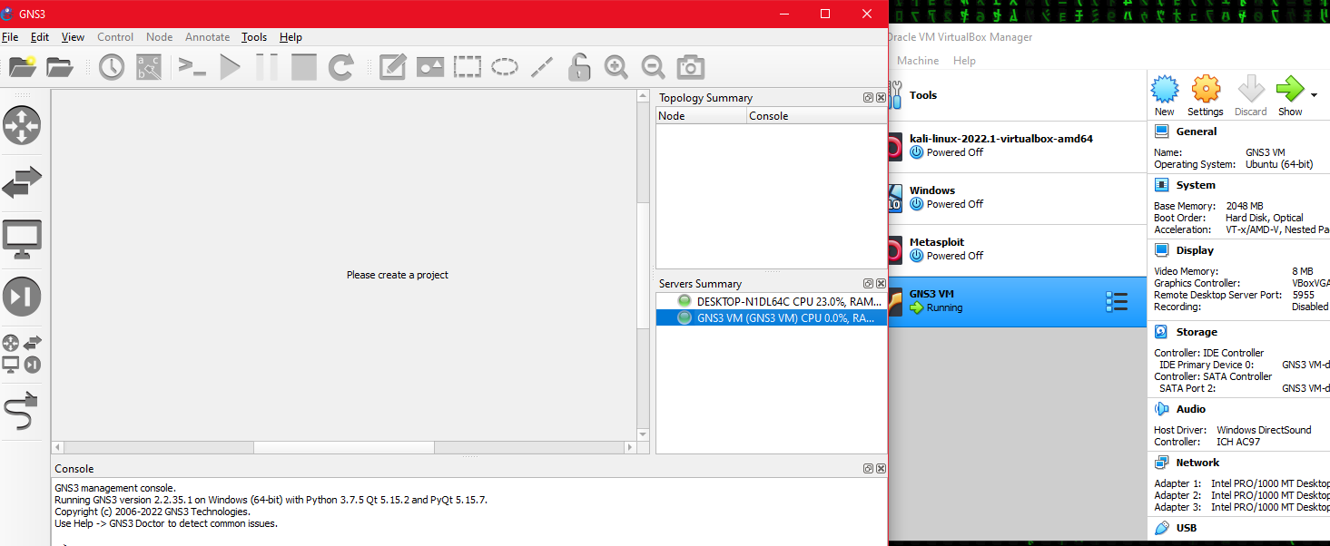
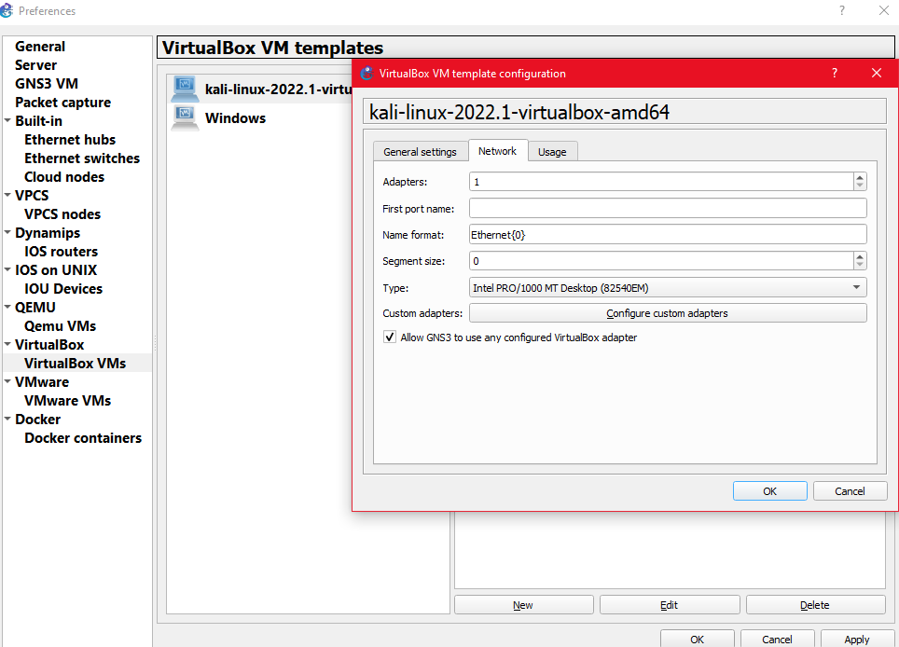
Then I added the Windows VirtualBox machine and Kali Linux into GNS3 with the Allow GNS3 to use any VirtualBox network adapter. (Cook, 2022)
After, I made a network topology using a CiscoIOSvL2 Switch and CiscoIOSv Router. I will need to use the putty console to add DHCP and bind both VMs to an IP address. (Cisco, 2020) (Cook, 2022)
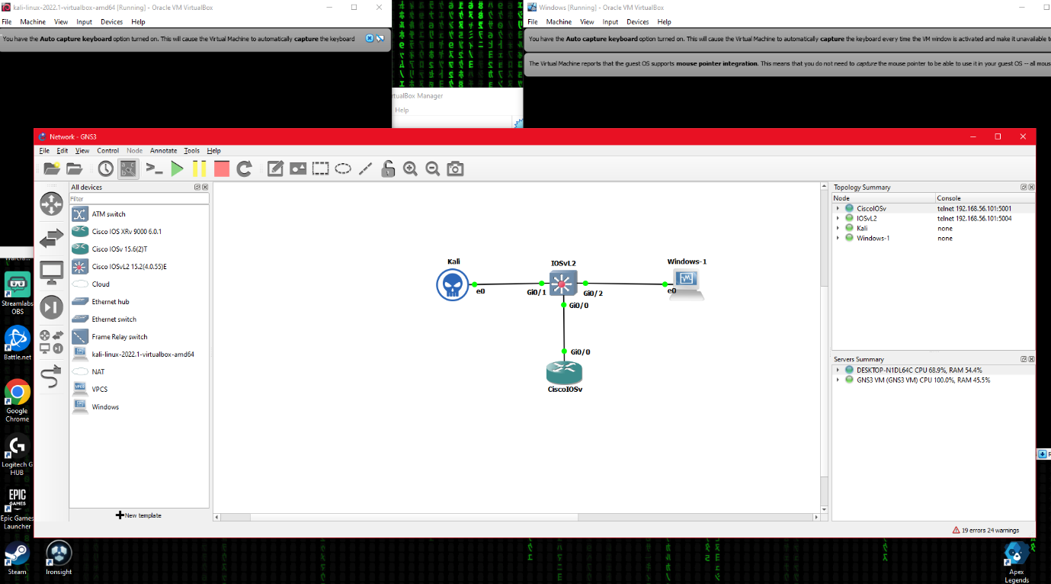
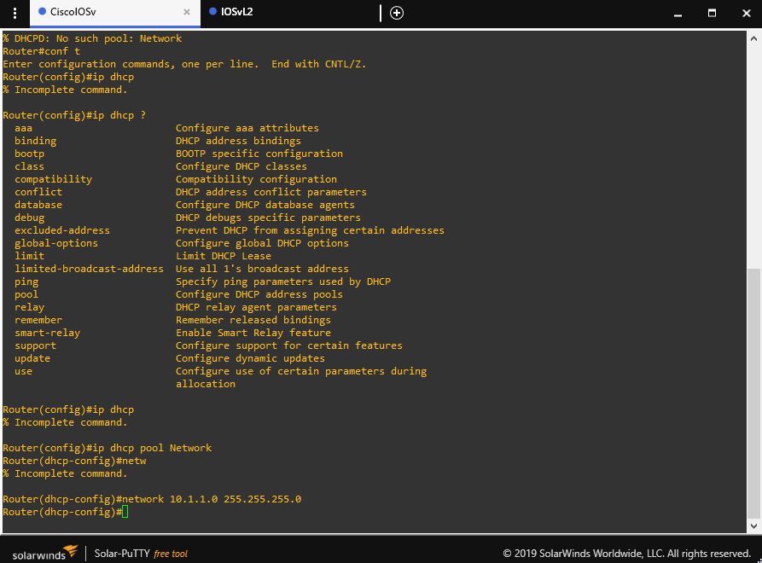

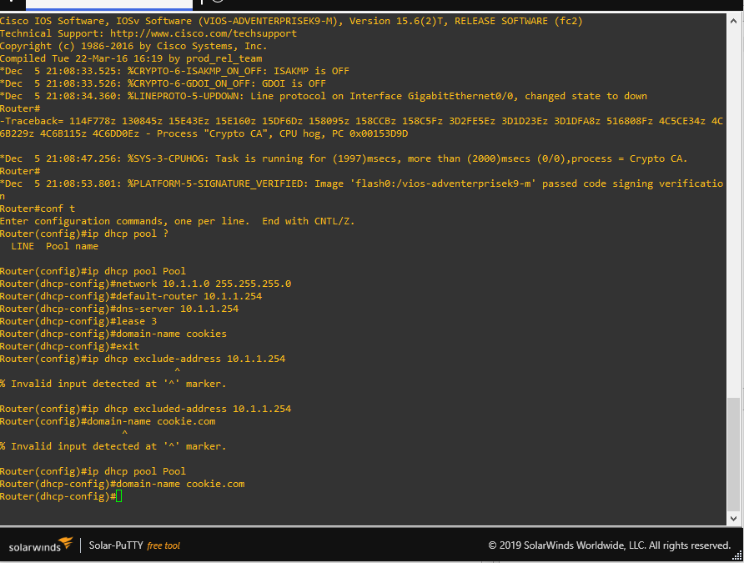
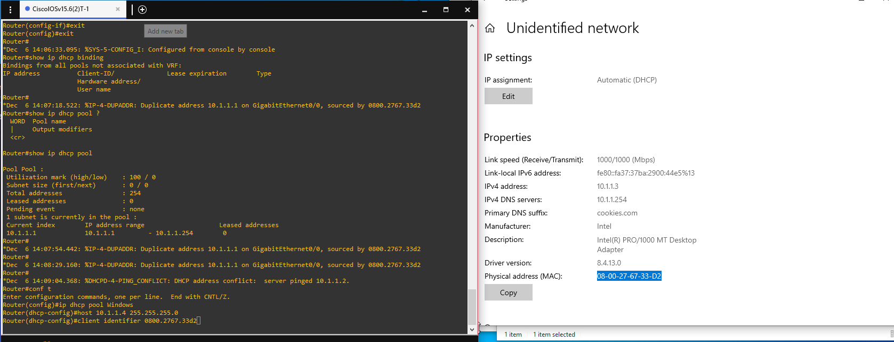
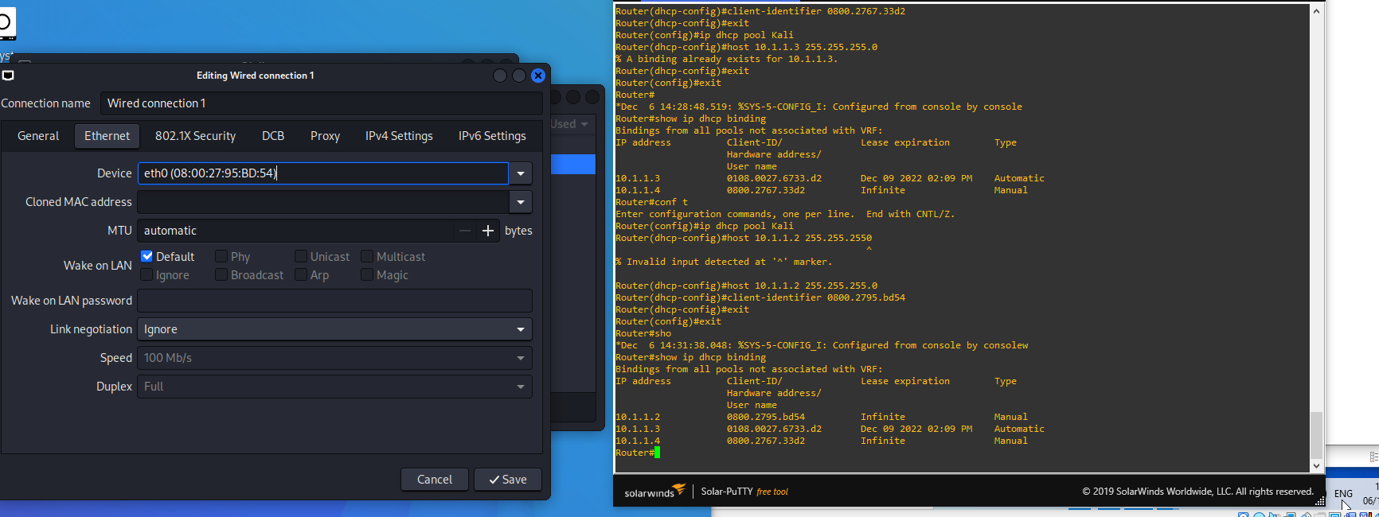
Binding mac address to IP in DHCP (Bombal, 2019) (Cook, 2022)
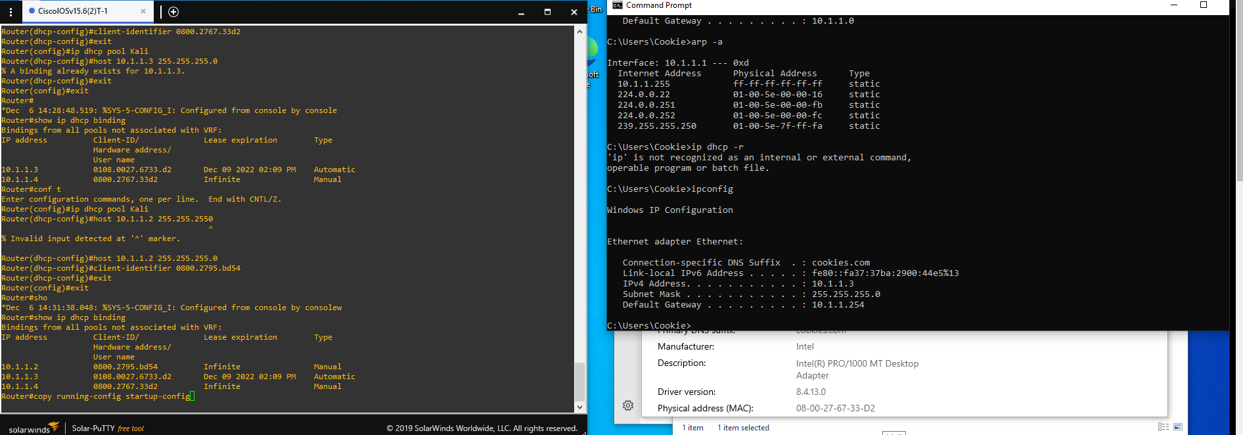
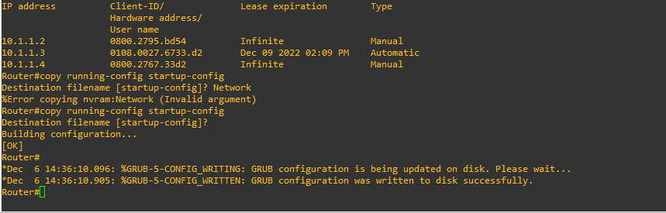
Saving router settings
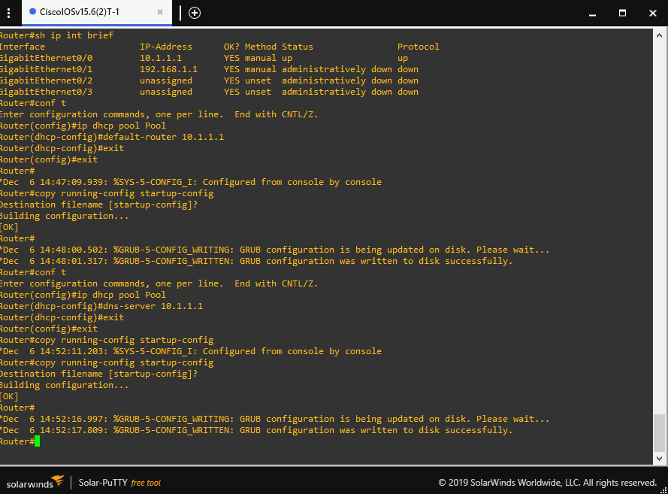
I changed the DNS and router address to what I set it to for the GigEthernet binding. (Cook, 2022)
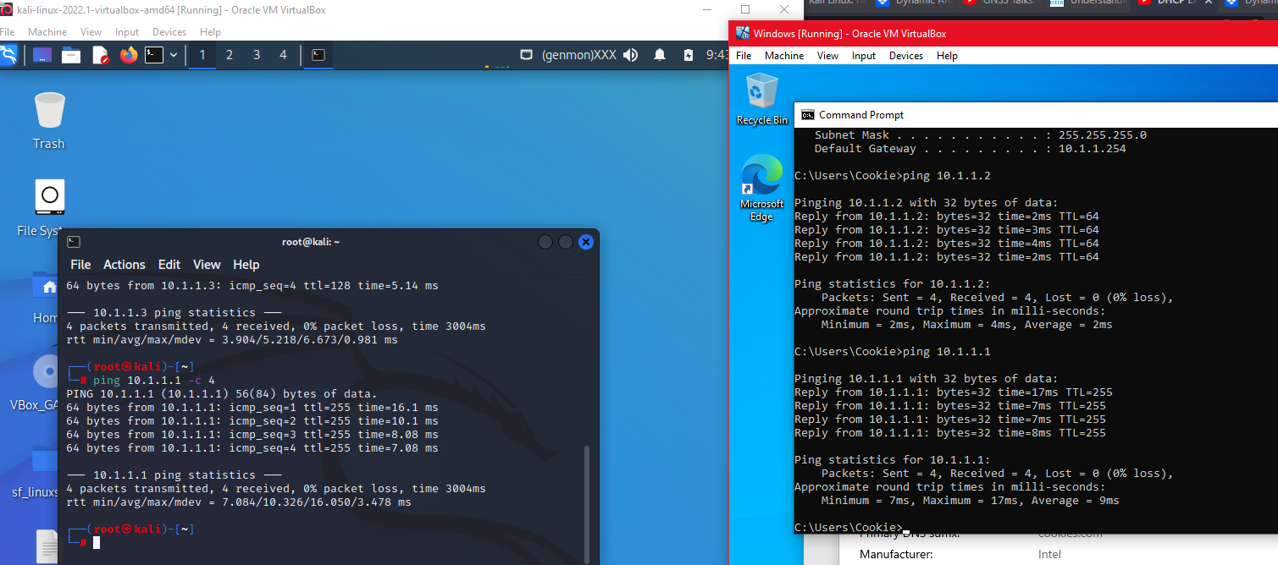
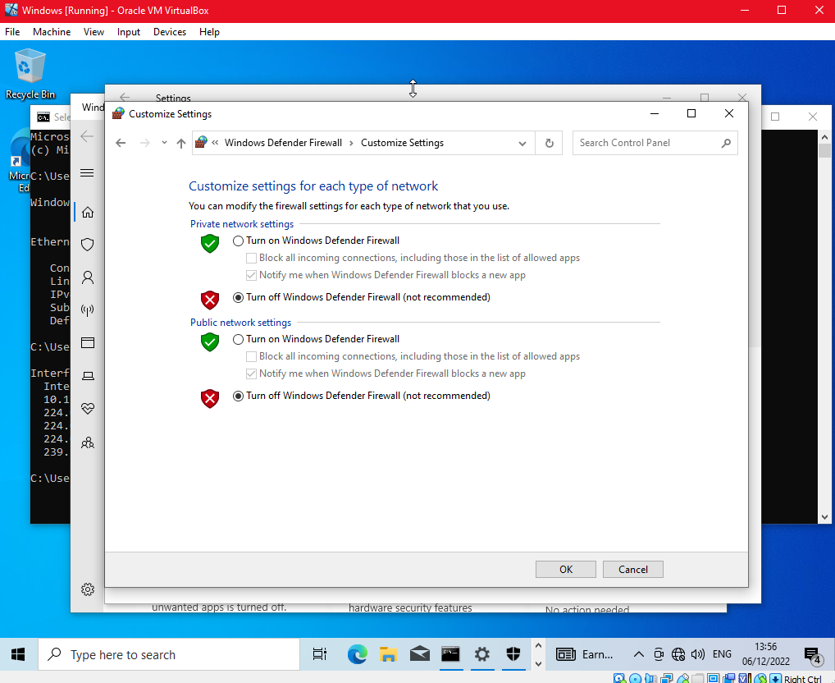
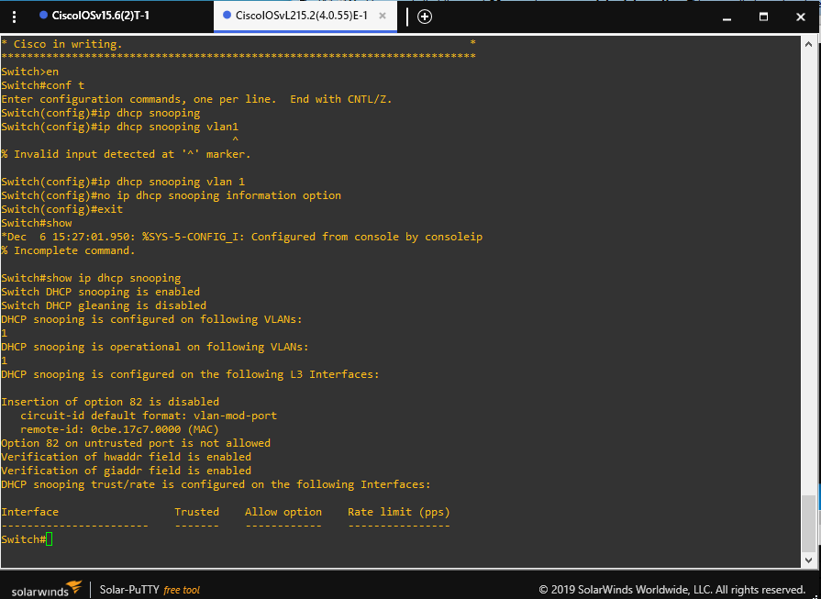
Configuring Switch for DHCP snooping (Bombal, 2020) (Cook, 2022)
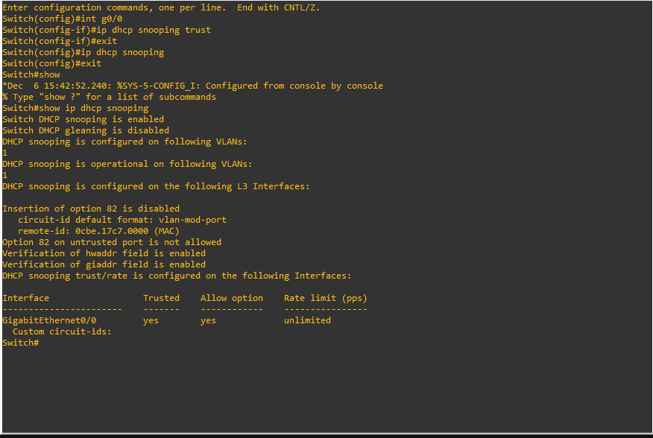
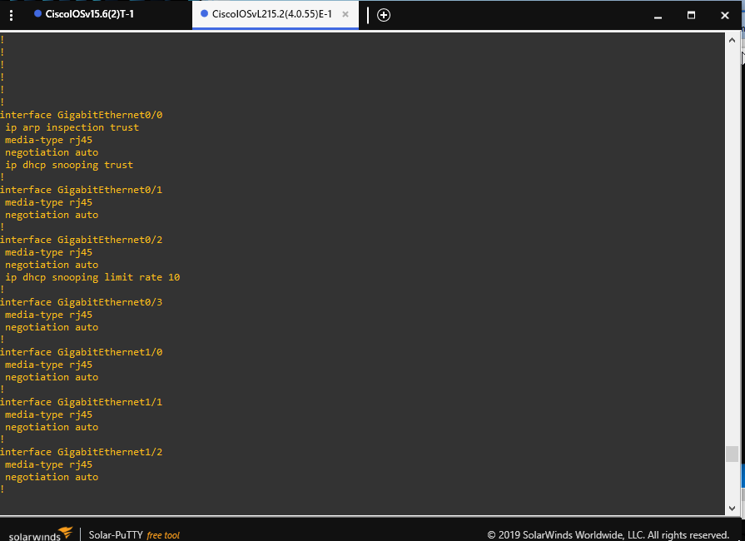
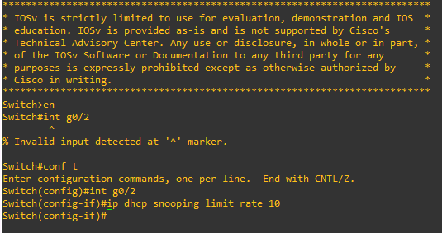
No IP addresses bound to DHCP Snooping, so need to disable/enable/release/renew IPv4 addresses (Bombal, 2020)
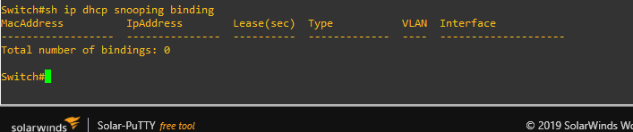
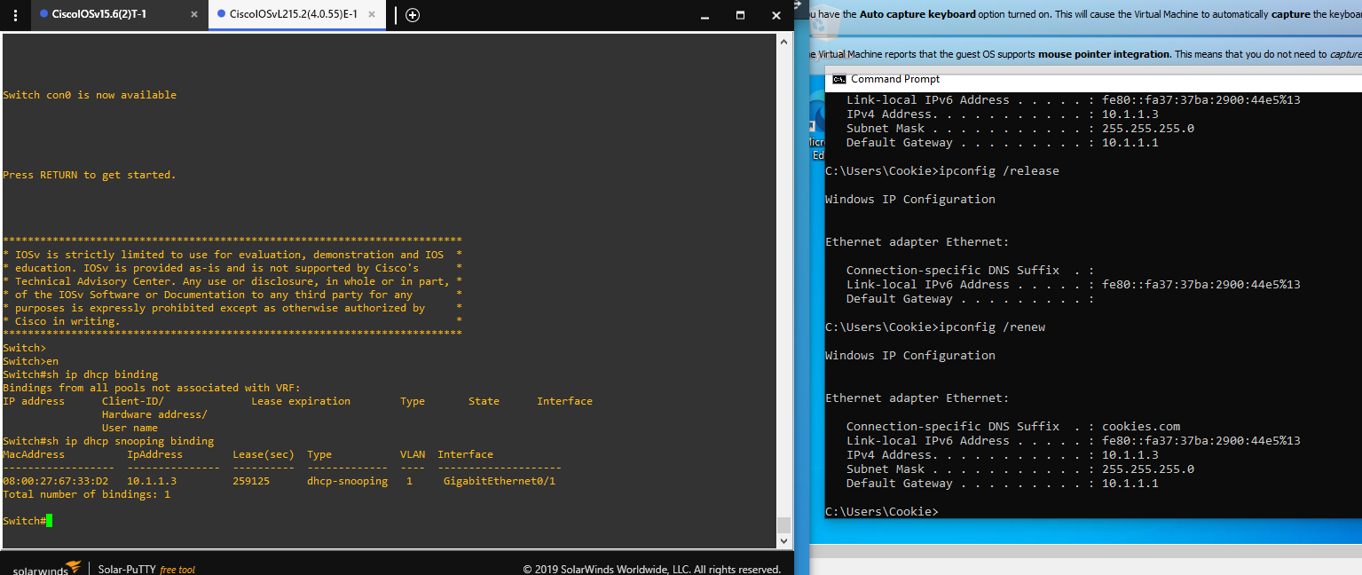

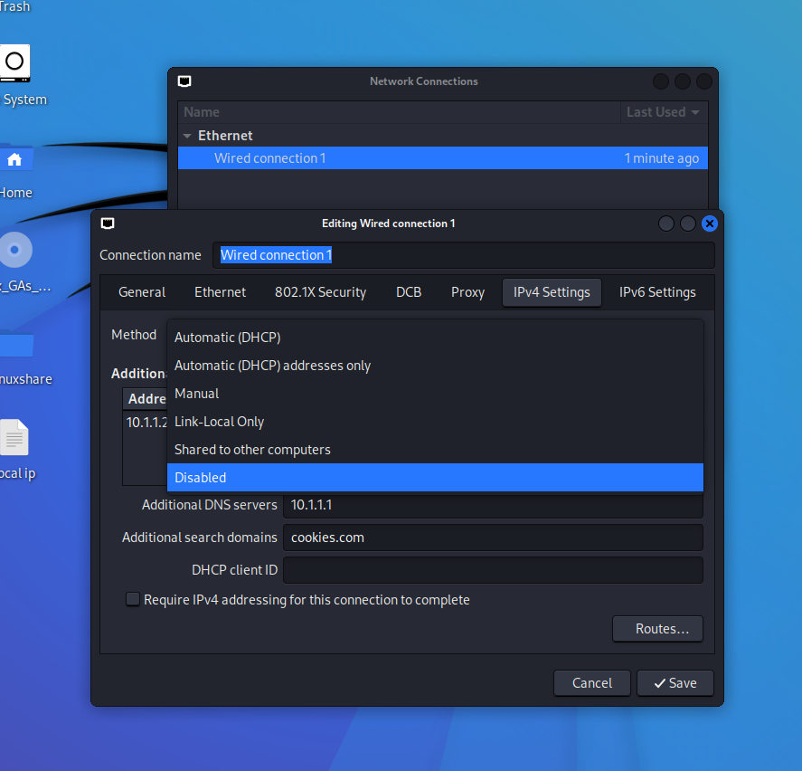
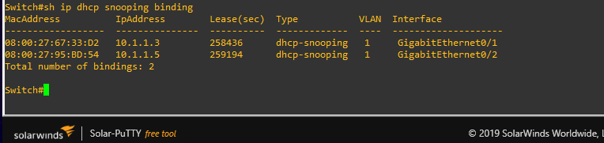
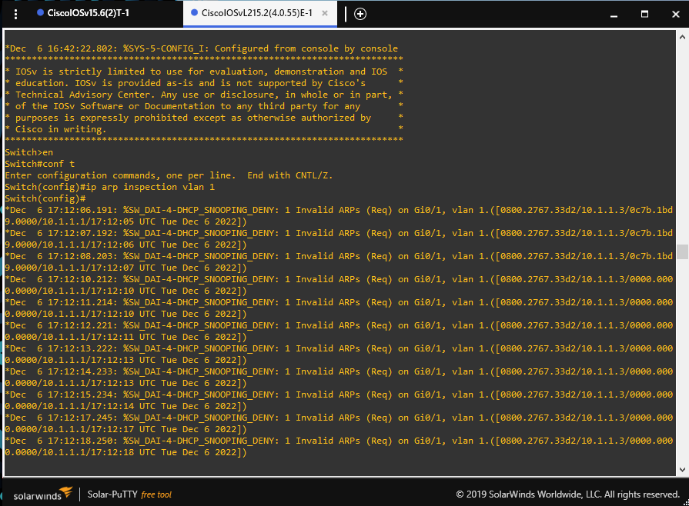
Setting up Arp inspection, but it forces to stop all traffic, that is an issue. (Bombal, 2020b) (Cook, 2022)
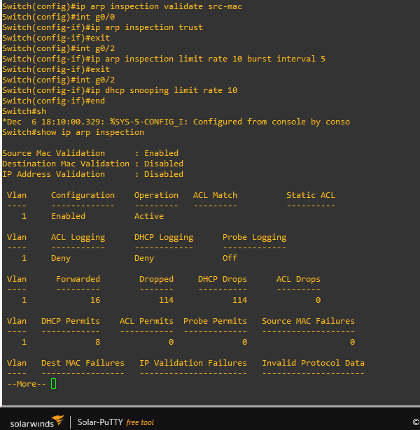
Stopping the ARP spam and assigning trust to the g0/0 eth connection (Cook, 2022)

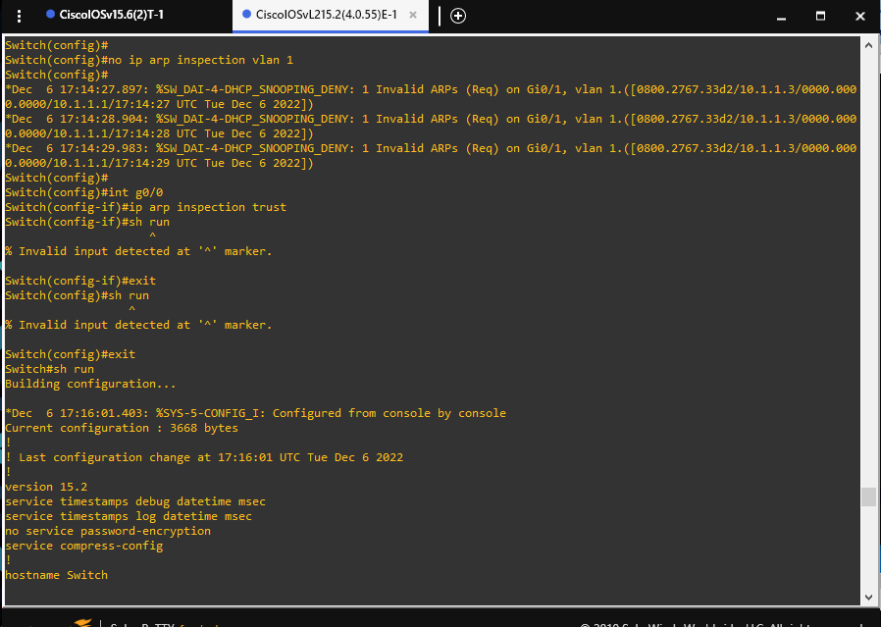
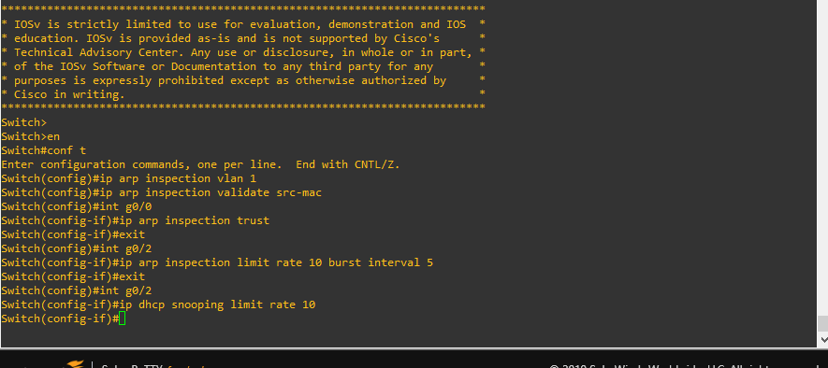
Now that DHCP Snooping and DAI are enabled, time to test. (Cook, 2022)
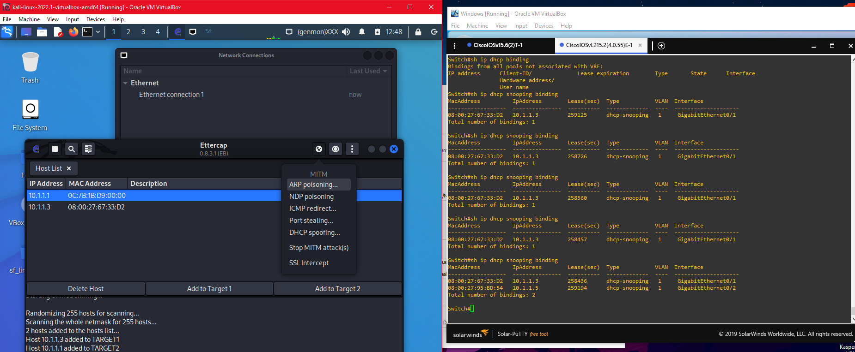
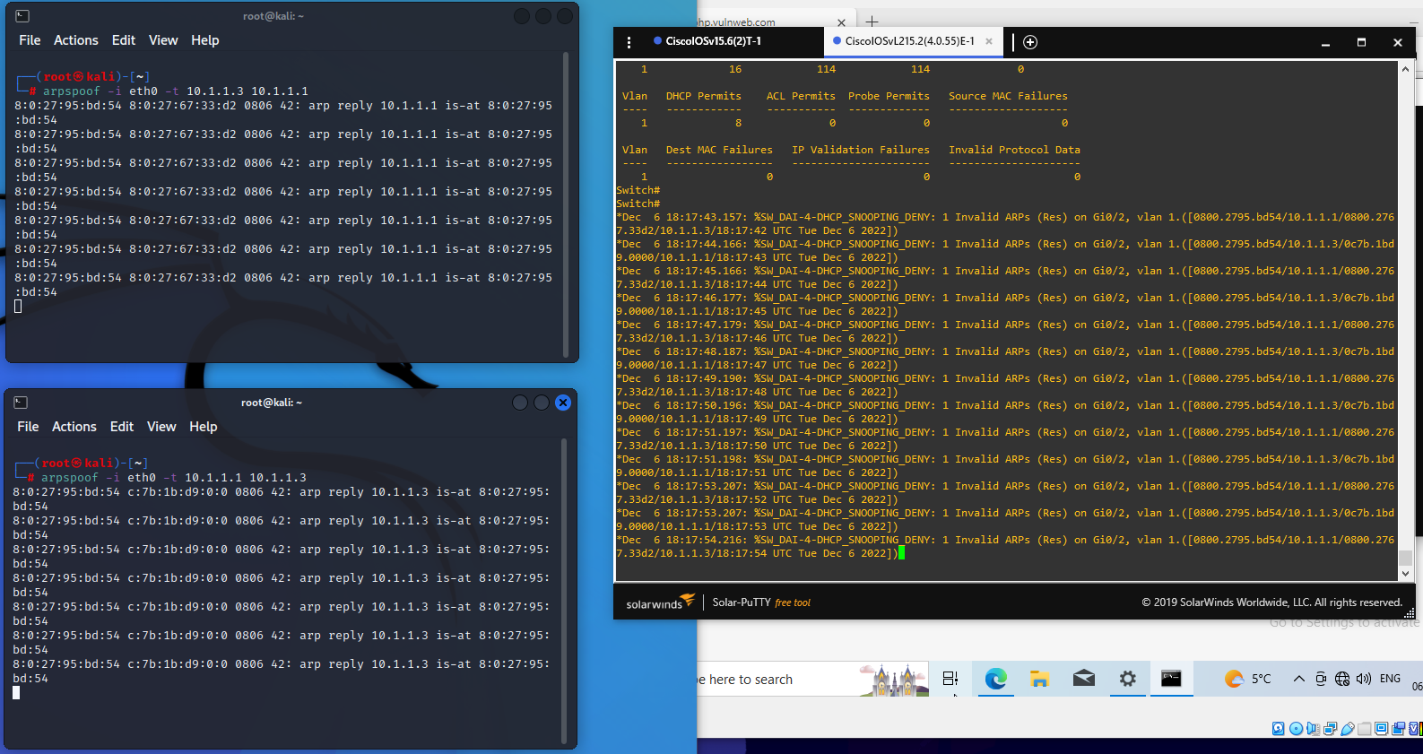
Using Wireshark to review network activity (Cook, 2022)
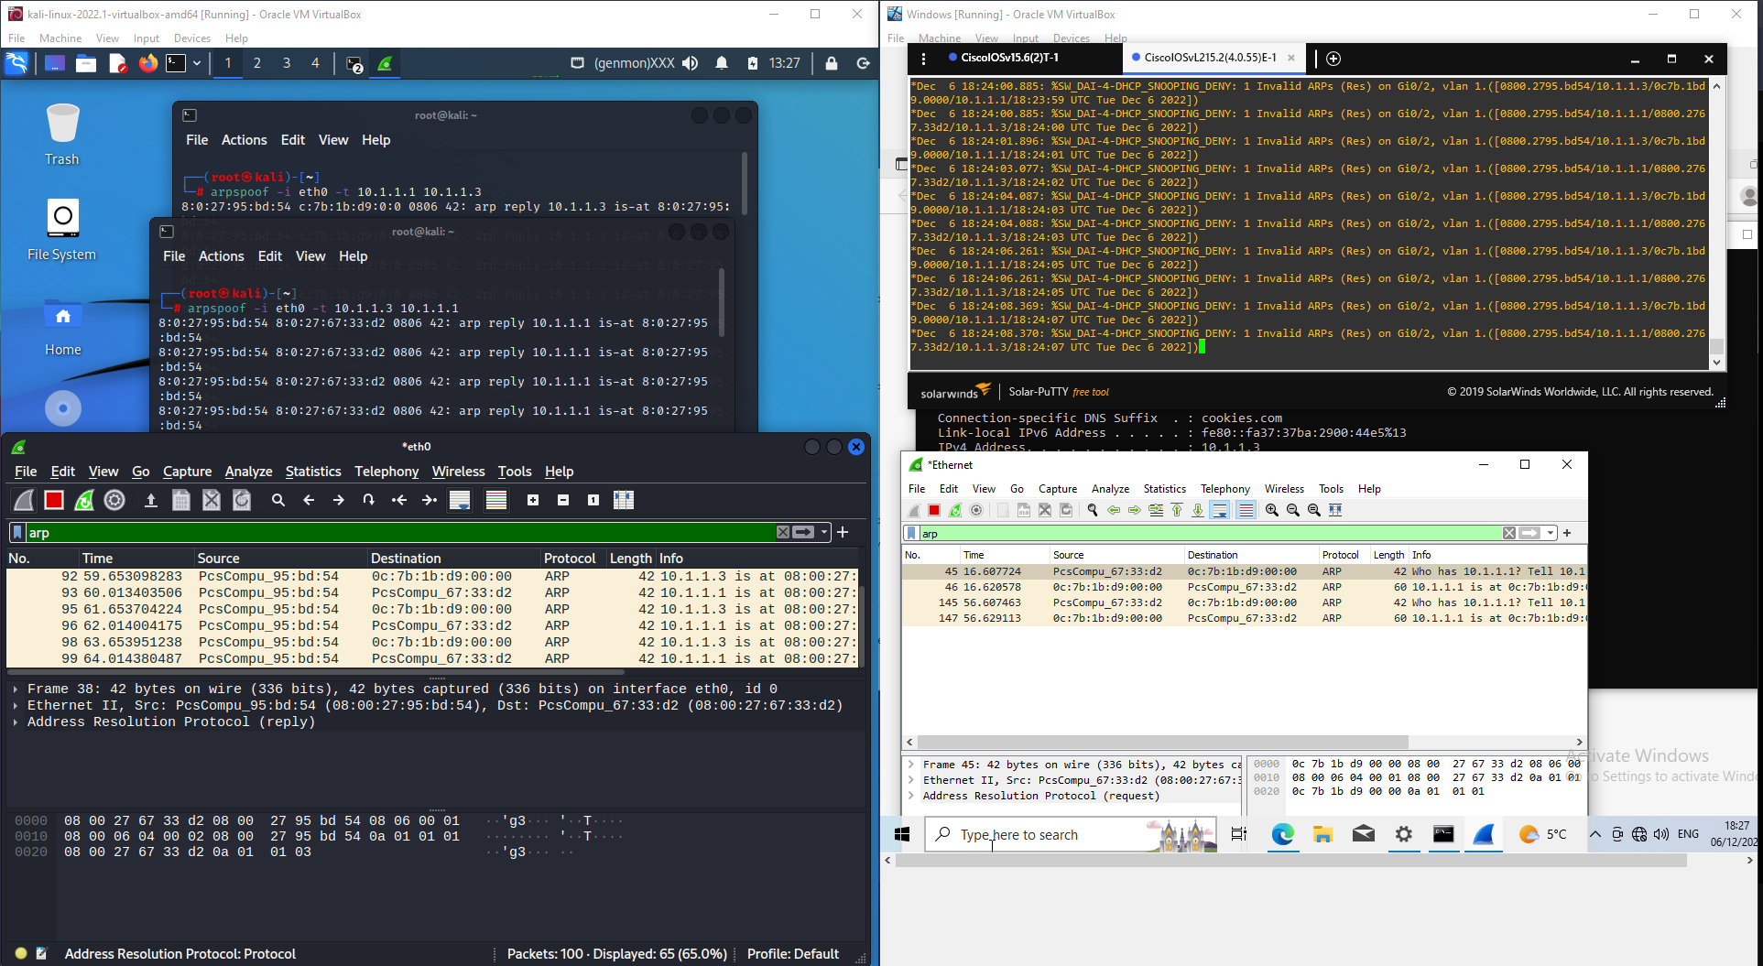

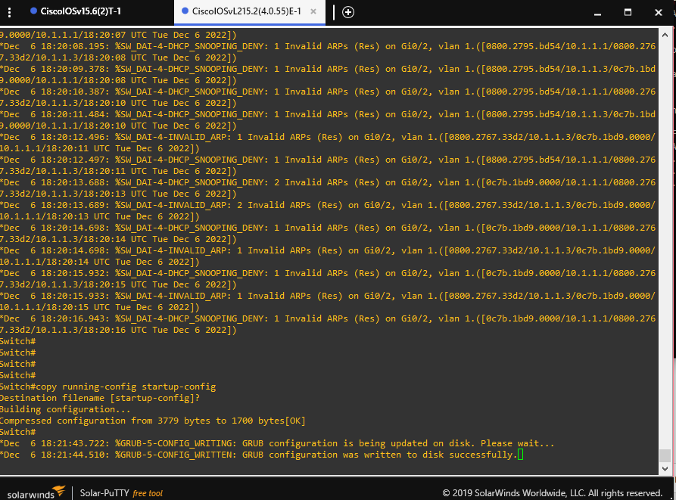
ARP mitigation was successful; Ettercap would not scan correctly and denied ARP Spoof from Kali terminal. (Cook, 2022)

3: Changing the IP network to provide a Class B network (default mask for class B is 255.255.0.0) for all three DHCP pools and the ethernet interface. (Cook, 2022)
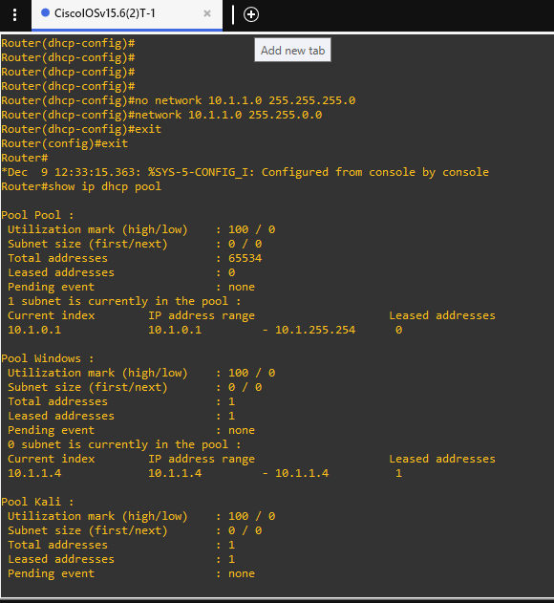
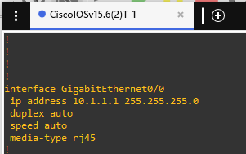
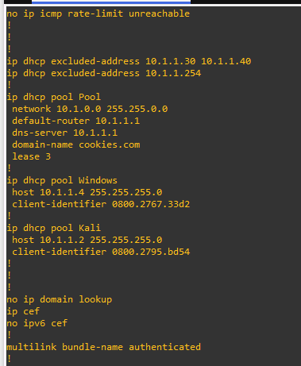
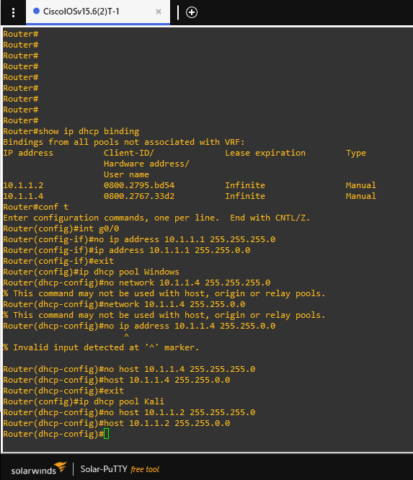
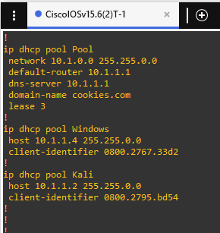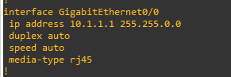
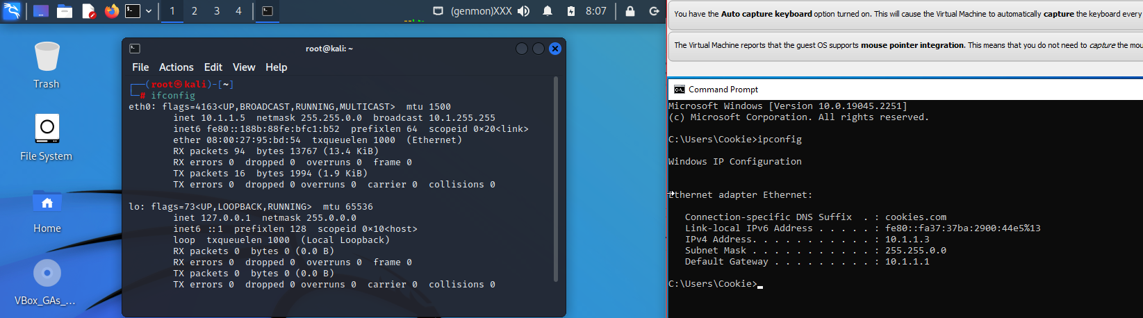

3a: Both clients can obtain IP and DHCP and communicate with each other (Cook, 2022)

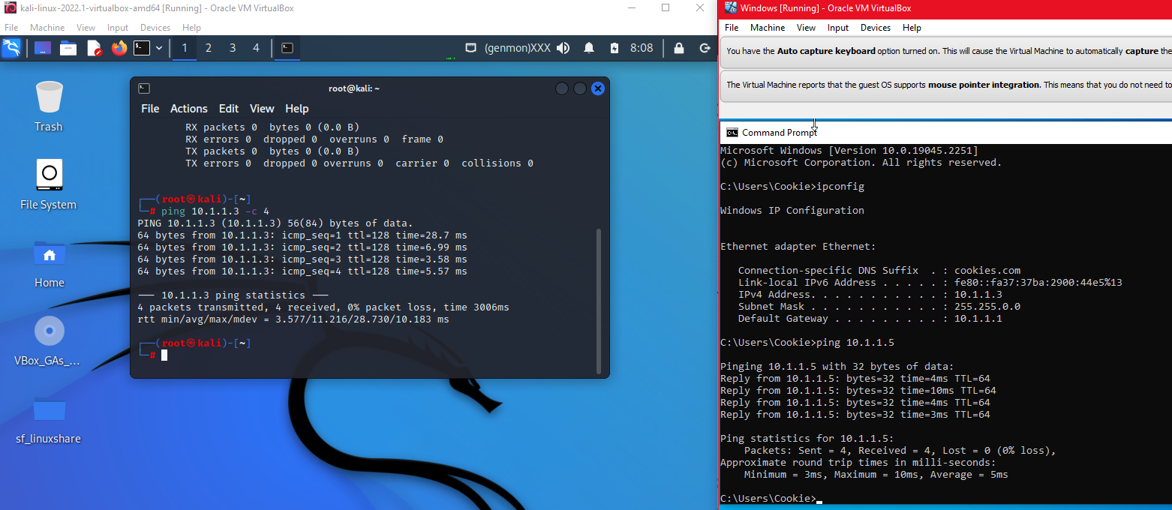

3b: Currently, there is a 65534 address. I need to update the total addresses to 126 with 512 subnet addresses as a class B network. (Cook, 2022)

This screenshot shows the ip DHCP pools for Windows, Kali and Pool, this shows data such as total addresses, leased addresses and subnets inside the pool.
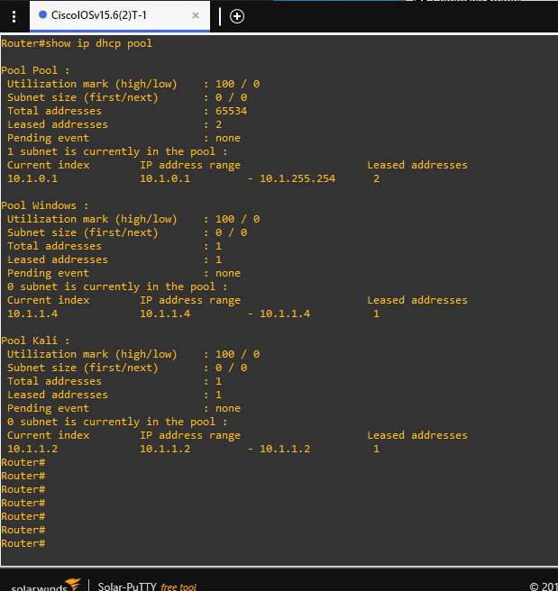
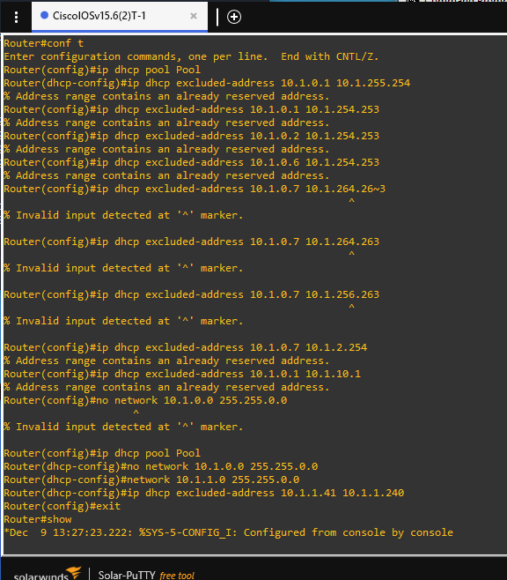
This did not prove easy without just resetting the router and setting it up from the beginning with the specified settings due to the DHCP pool. The Pool IP address range is too extensive, and excluding addresses would not change it. (Cook, 2022)

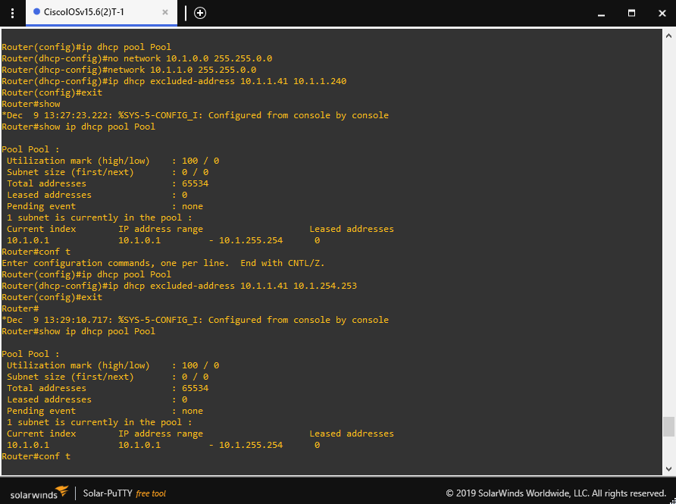
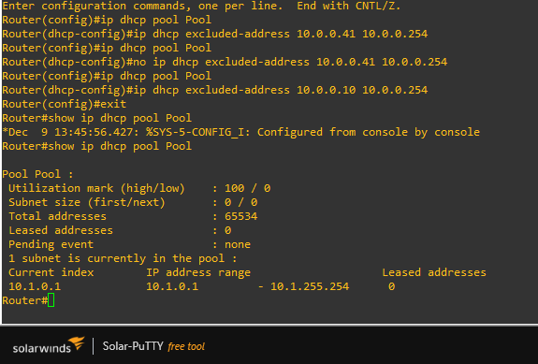

3b: I reset the router and redid all the DHCP, so it has 126 addresses available and 512 subnet addresses. (Cook, 2022)

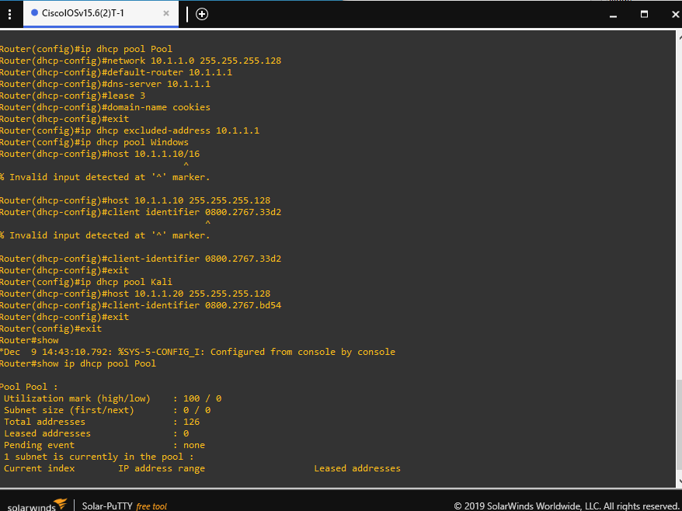
These screenshots show the configs for the pools ie. Kali, Pool and Windows this sets the DHCP config to set the network IP’s, DNS servers and domain name, as well as host and client identifier.
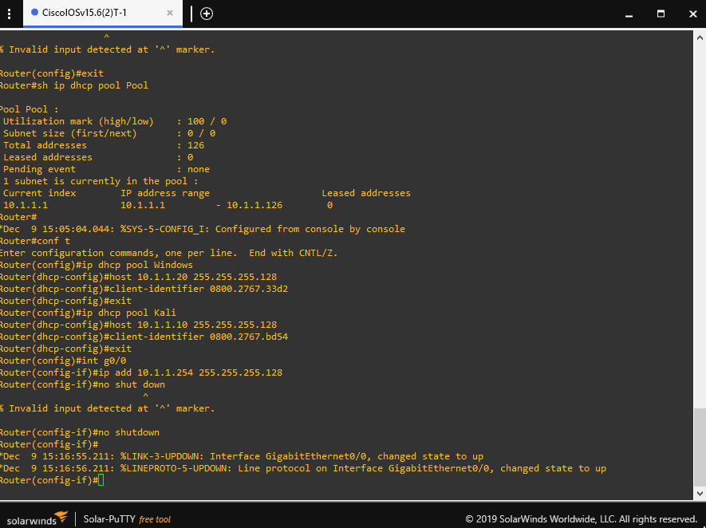
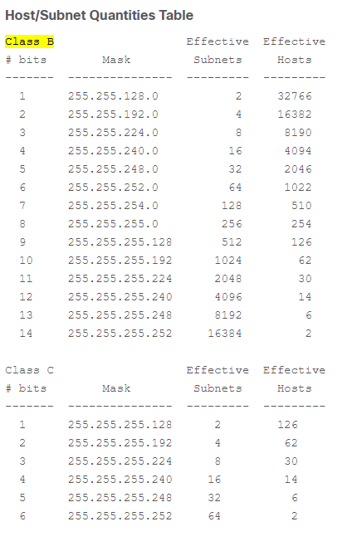
Image from - (Cisco, 2017)
I needed to bind IP addresses to VM clients, so I changed network settings from NAT to Generic Driver for both. (Cook, 2022)

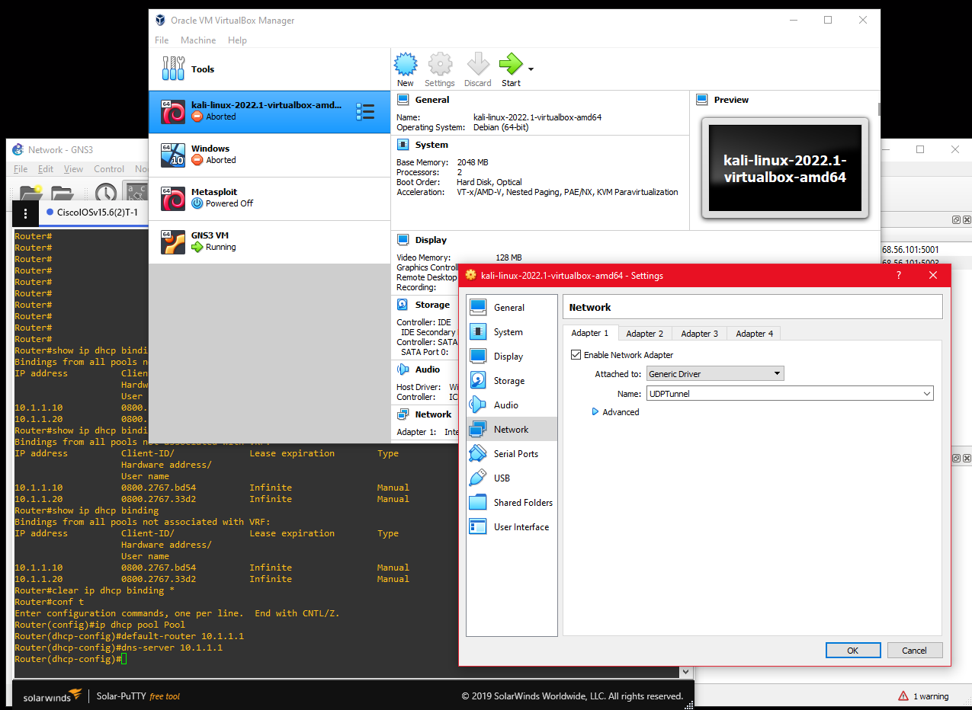

3b: With Class B network as a subnet with 512 addresses.
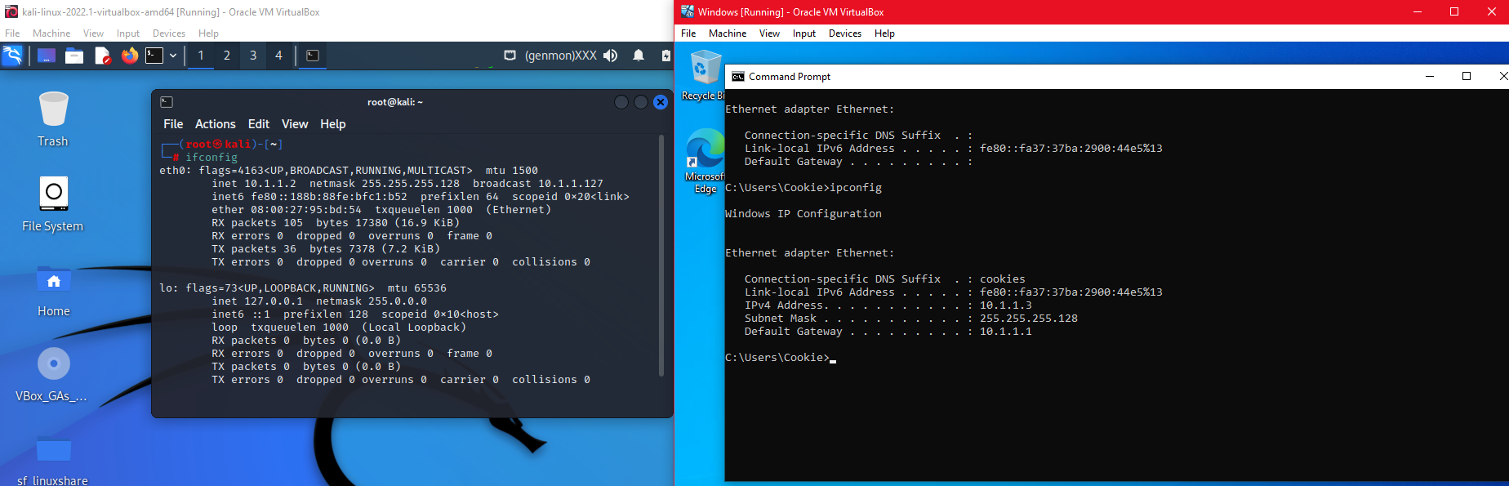
3c: Verifying client can obtain an appropriate IP address via DHCP
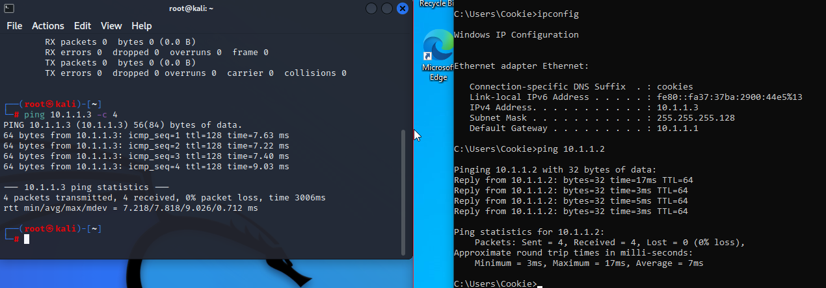
This screenshot shows the ip dhcp bindings with the Client-ID/Hardware address for 10.1.1.2, 10.1.1.3, 10.1.1.10 & 10.1.1.20.
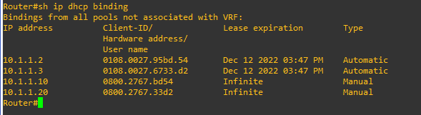

3e: Setting Windows client to static IP, under subnet Windows and cannot ping Kali client.
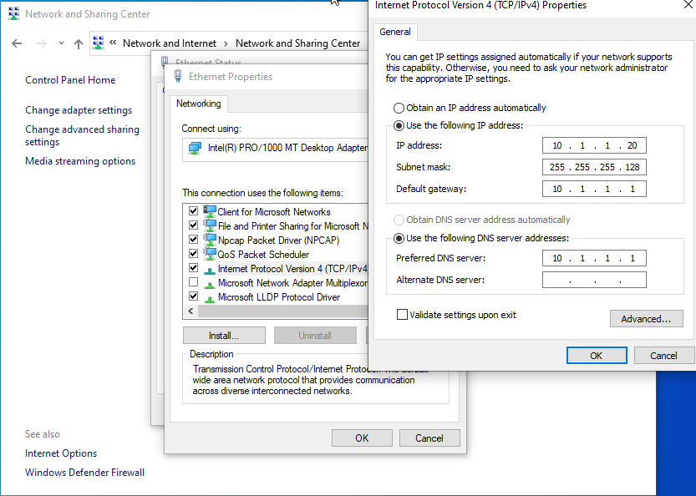
No ICMP requests could get captured on Wireshark.
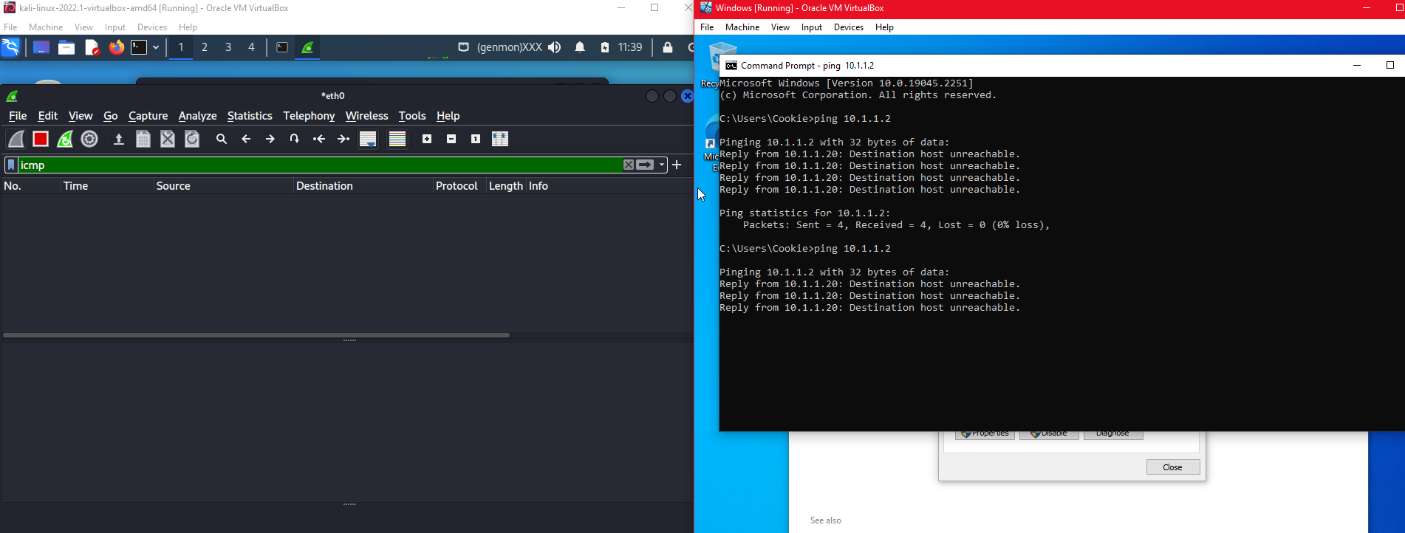
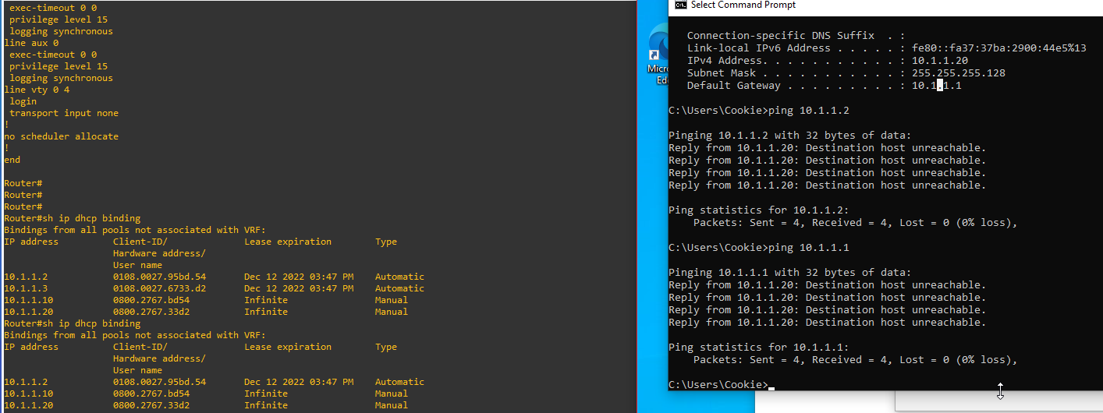
Changed the mac address binding to static IP address
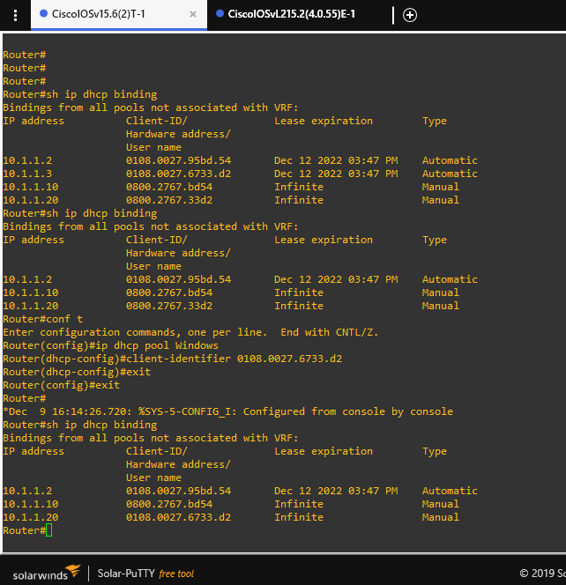

3d: Set Windows client to static IP address and can ping/communicate with Kali clients IP. Set network protocol config back to automatic as static IP was made manually in the router DHCP pool. (Cook, 2022)

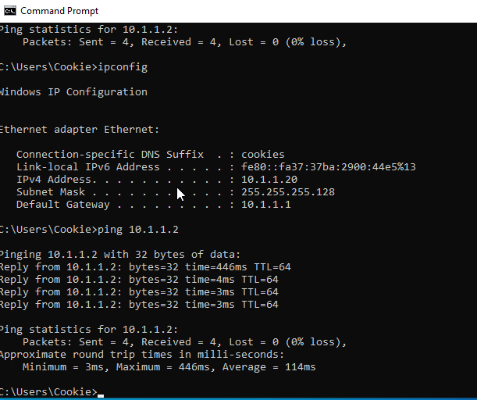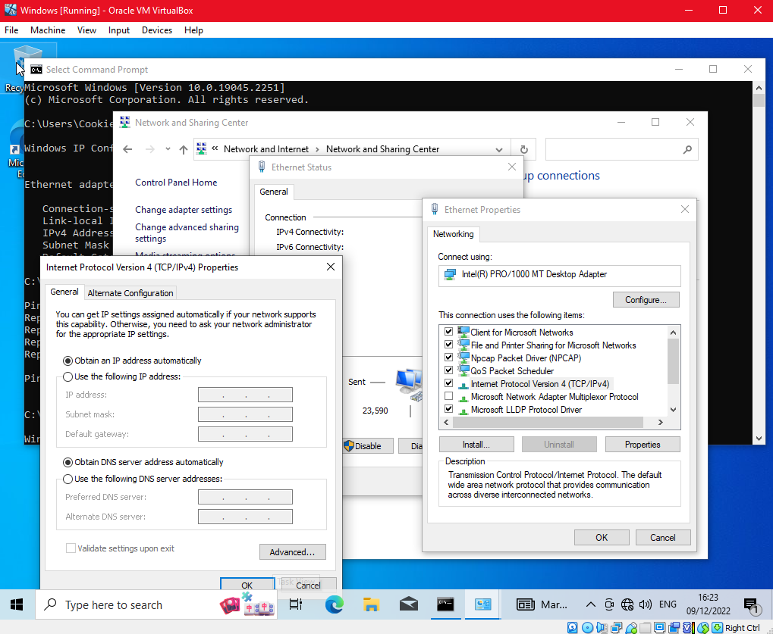
Using Wireshark to monitor ping requests (Cook, 2022)
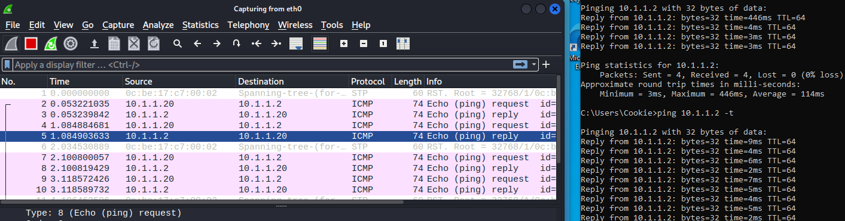
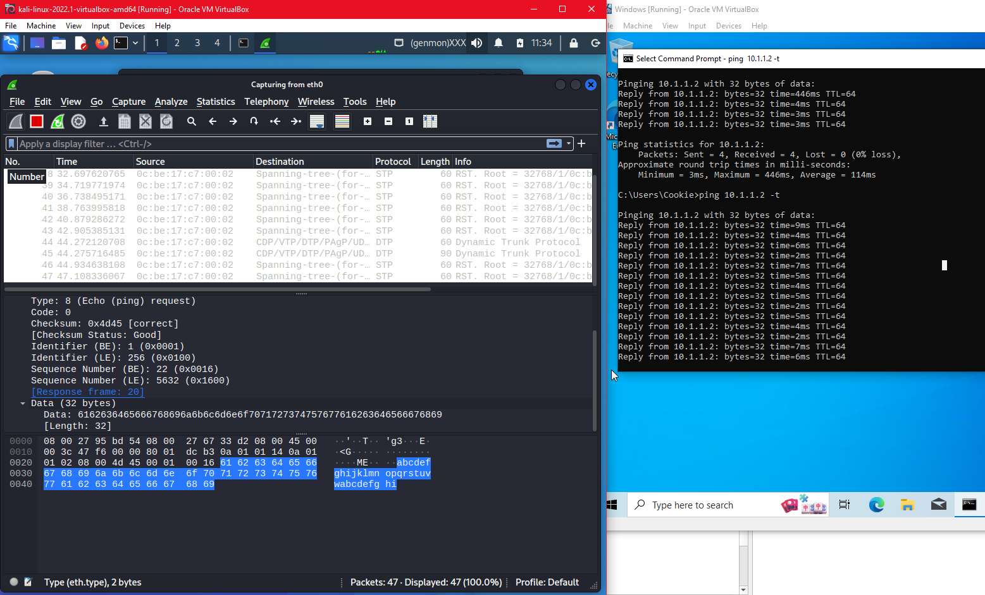

4a: Adding SSH service to the network & adding cloud internet to GNS3 to make it externally accessible.
(mpossible, 2018) (Cook, 2022)
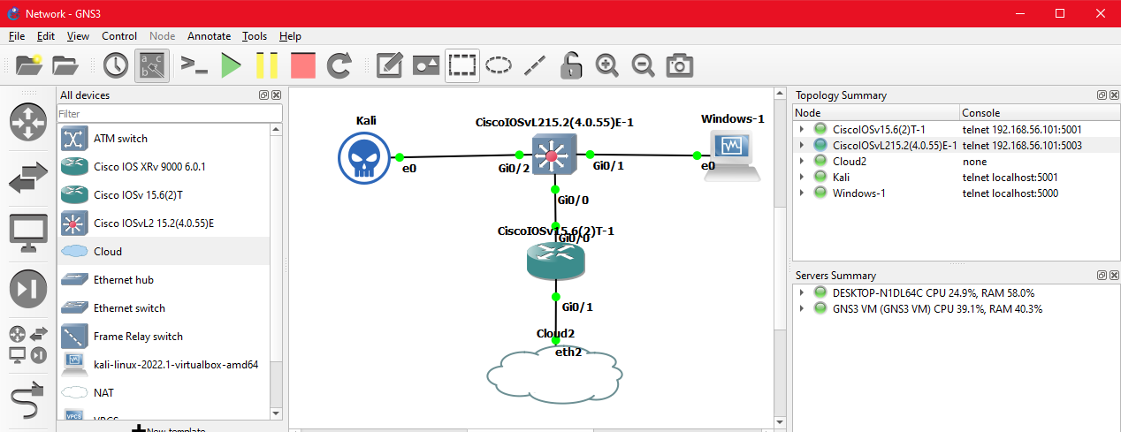
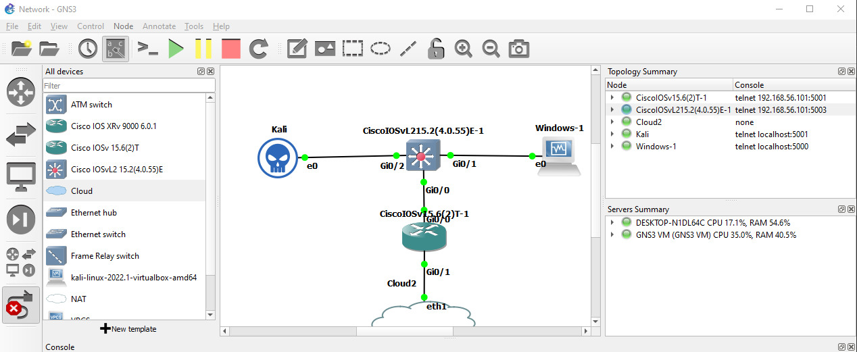
Changed the eth2 to eth1 (Bombal, 2017) (Cook, 2022)
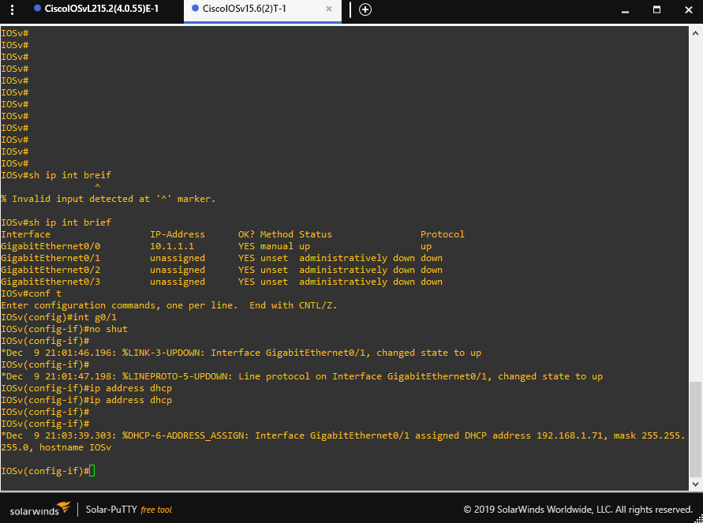
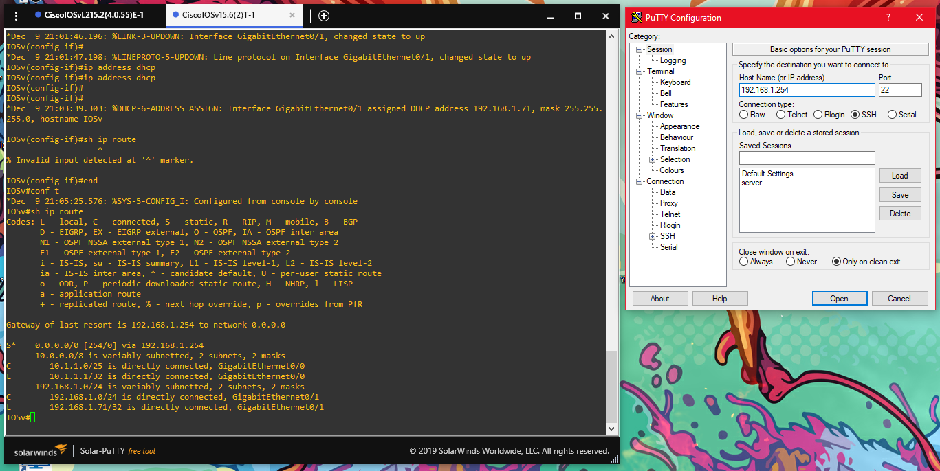
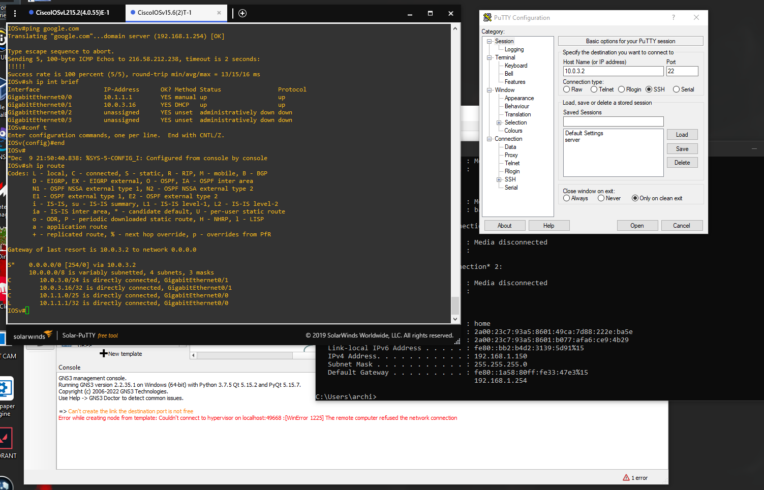
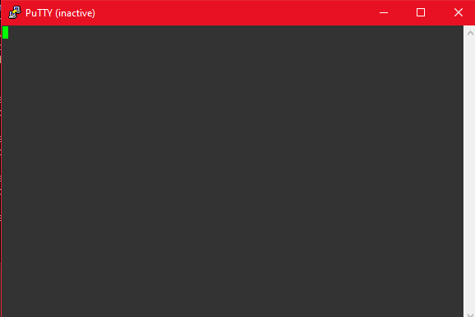
Unfortunately, whilst using GNS3, it does not want to connect to the internet, allowing the router’s SSH to be externally accessible. (Cook, 2022)
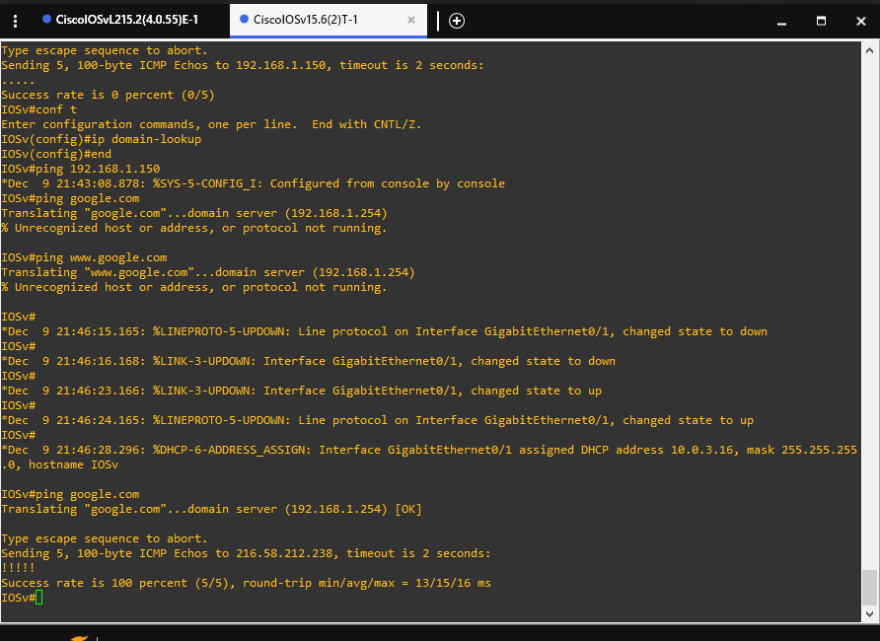

4b: Secured the SSH by using a password, secret, auth timeout and max three retries for the password. (Cook, 2022)

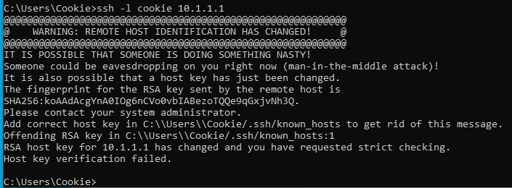
This screenshot shows the terminal of me attempting to connect to the network through SSH however it shows that the Host key verifaction failed and gives me an error/warning message.

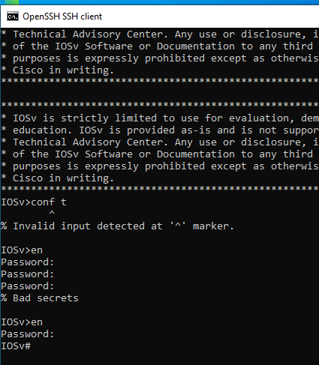
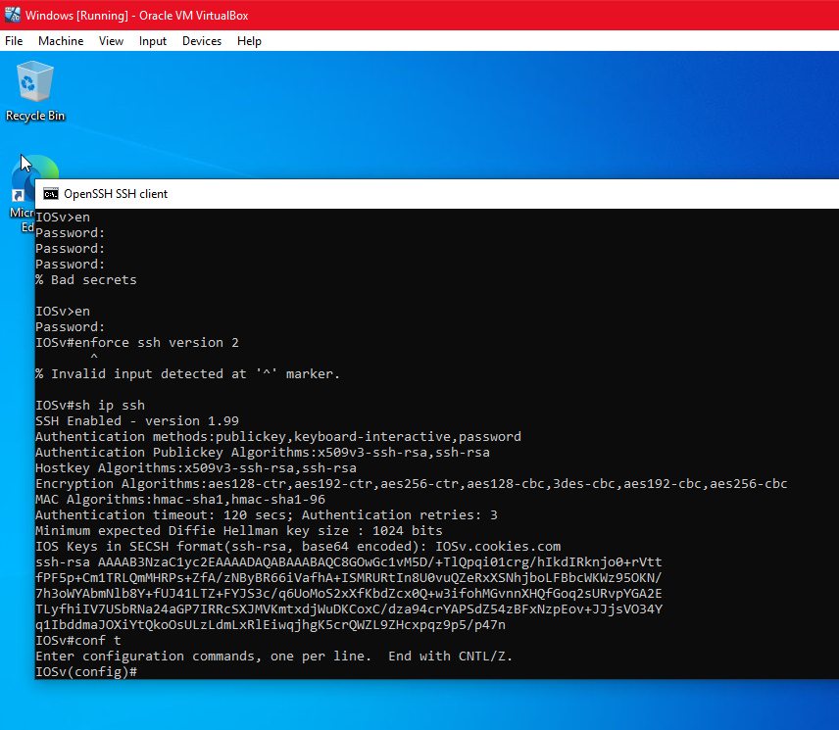
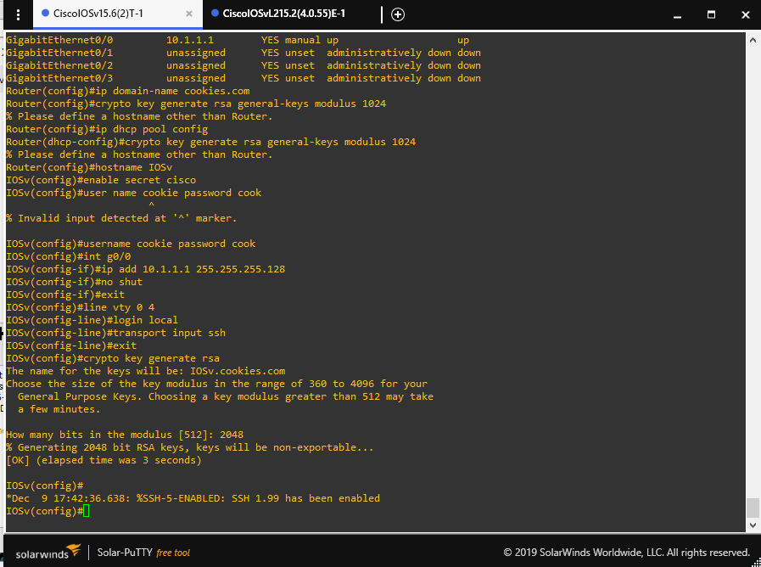
This screen shot shows me inside the config of CiscoIOSv15.6 routers config settings, editing the ip domain name, generating crypto keys (crypto key generate rsa general-keys modulus 1024), ip DHCP pool config, adding ips to g0/0.

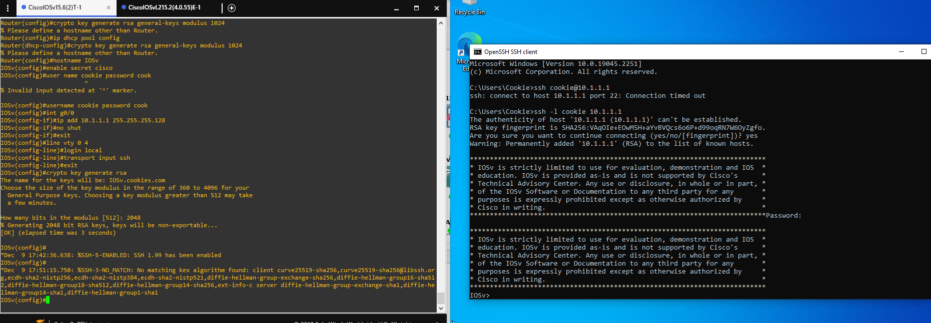
This screenshot shows the router settings and a successful SSH connection to the router through terminal.

4a: Installing OpenSSH server to Kali client, running it on the network and verifying it is accessible from the Windows client. (Cook, 2022)

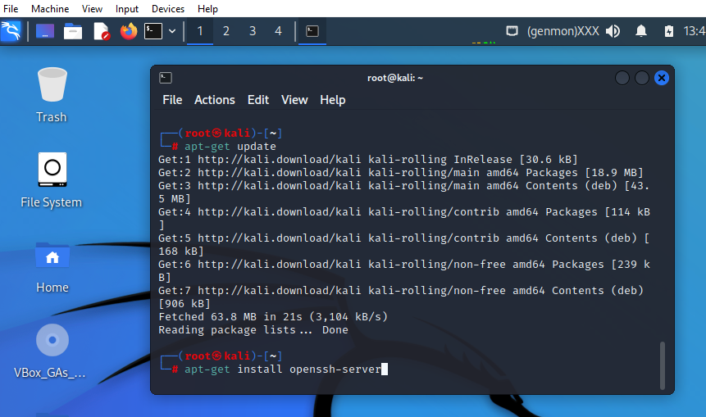
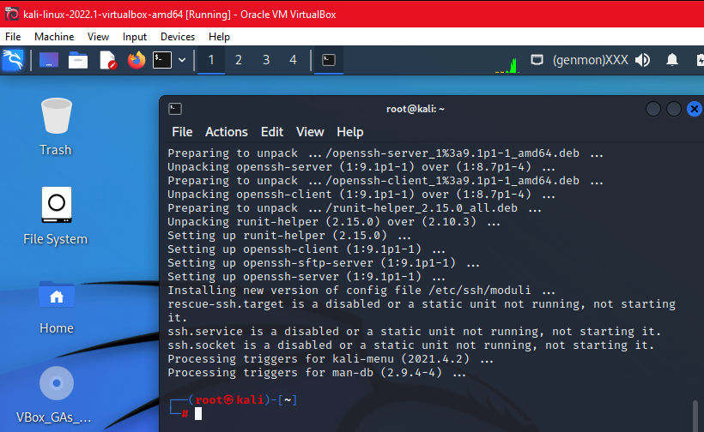
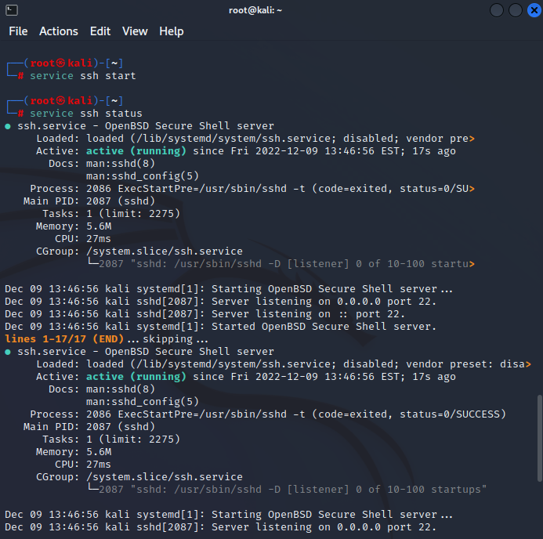
Changing the hostname of the client SSH service (The Digital Nomad Guy, 2016) (Cook, 2022)
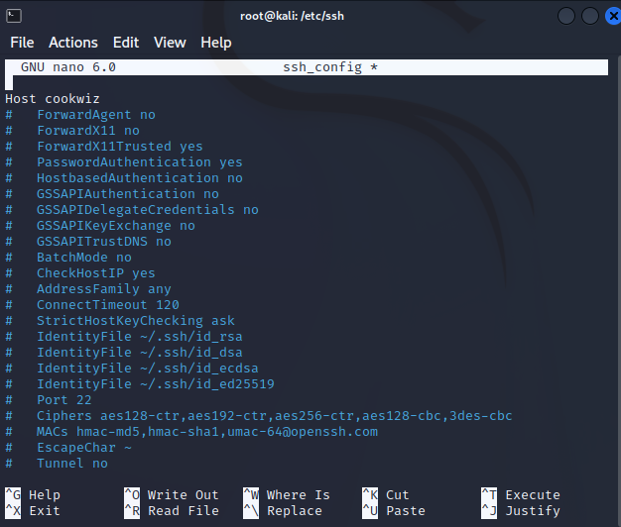
(The Digital Nomad Guy, 2016)
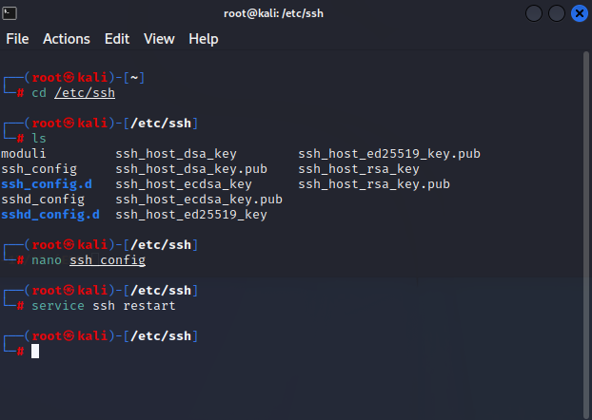

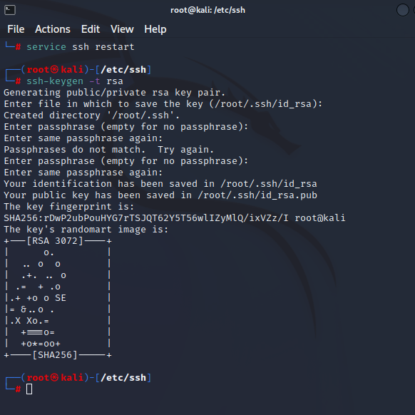
Downloaded gedit through the terminal and run it, then changed the SSH config to allow root login. (Cook, 2022)

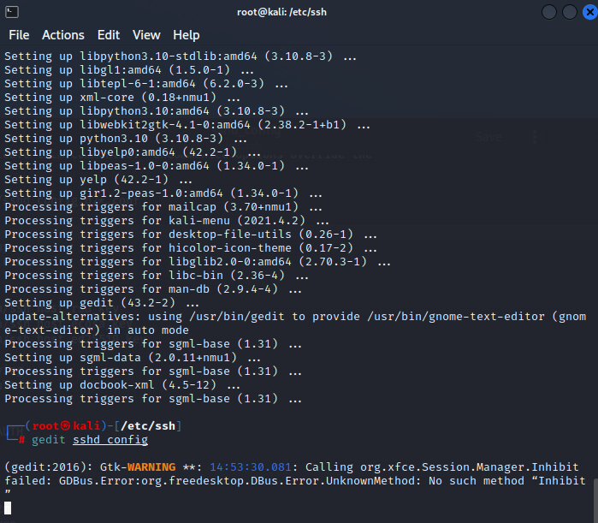
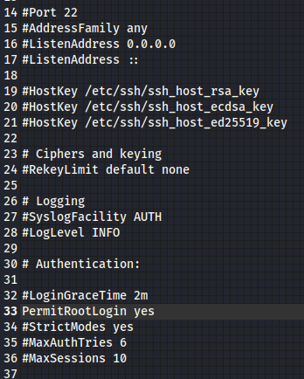
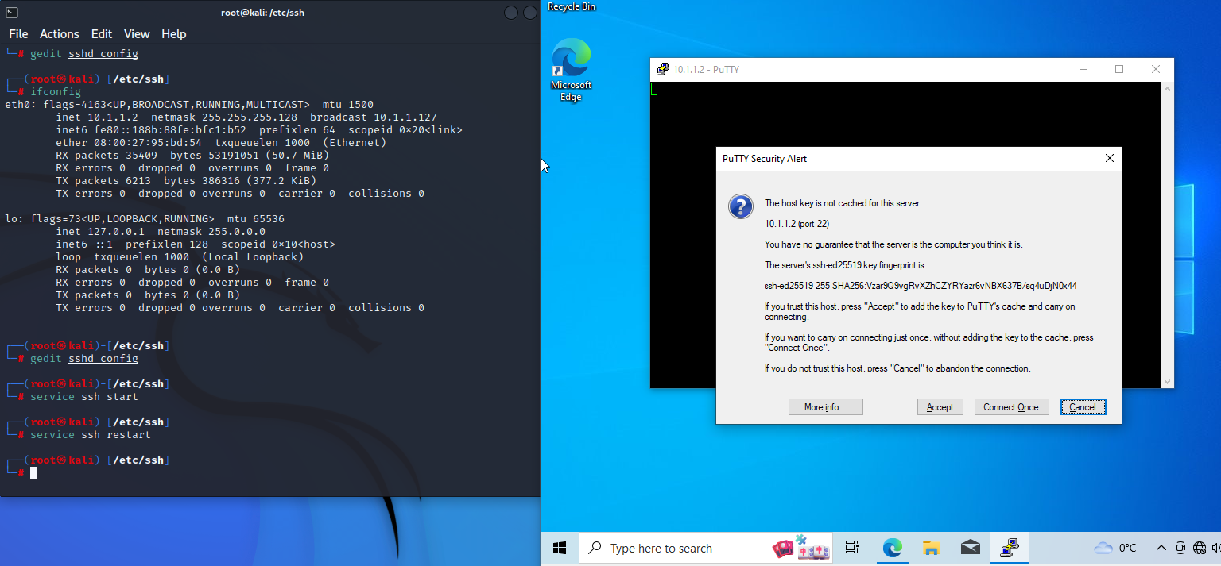
Below shows client is accessible from another client on the same network. (Cook, 2022)
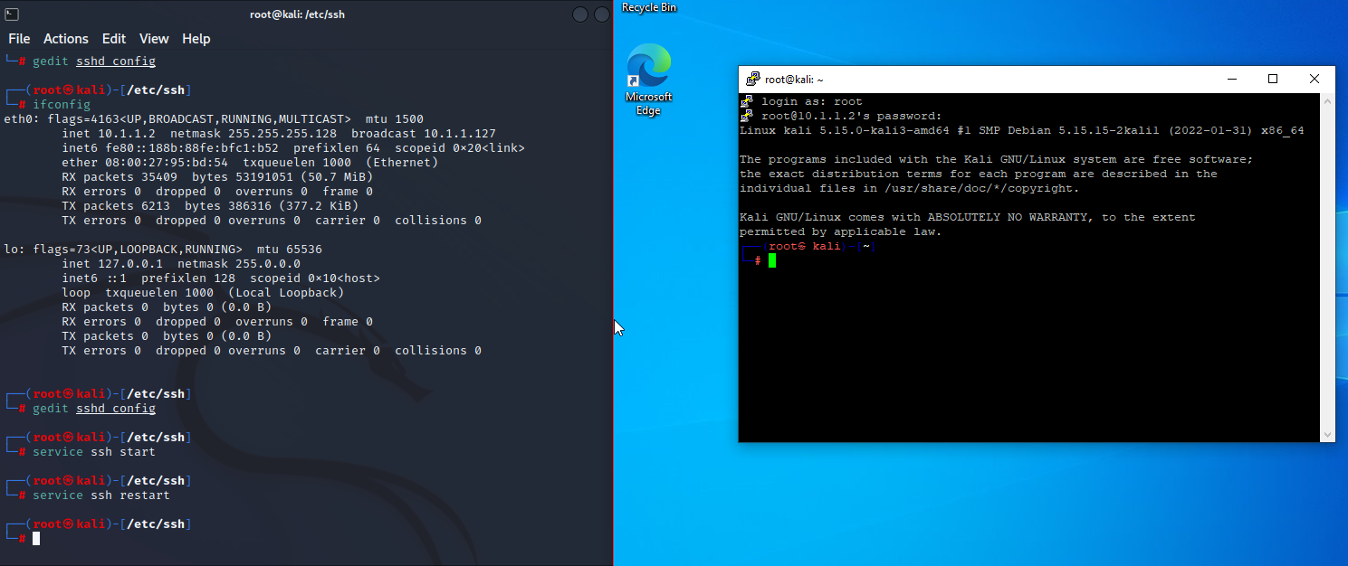

Conclusion:
In the end, this project gave me a full understanding of network tasks. From basic setup and security to advanced simulation and virtualization. Gaining practical experience with GNS3, Cisco devices, and different network tools helped me understand network management and security complexities. It also showed the need to adapt and keep learning in network administration, with rapidly evolving technologies and best practices.
Dealing with challenges like setting up a Class B network and securing SSH showed the intricacies of network setup and security. Using Wireshark to monitor network activity was key to understanding and fixing network issues, showing the importance of monitoring tools.
The project also emphasized the importance of clear documentation and communication in network administration. Detailed cataloging of tools and software used highlighted the need for thorough documentation to manage and maintain networks easily.
Overall, the project improved technical skills in network administration and deepened the understanding of the wider context in which network administrators work. It reinforced the need for continuous learning and adaptation in the fast-changing IT and network administration field. The practical experience gained will be invaluable in future network tasks and projects.
Finally, I would also improve my approach by going into a lot more detail on how I secured the network and the observations for the capabilities and restrictions for each. (Cook, 2022)

References:
Bombal, D. (2017). GNS3 Talks: How to connect GNS3 to a physical network (Part 1). [online] www.youtube.com. Available at: https://www.youtube.com/watch?v=Gpje9PV1j8U [Accessed 9 Dec. 2022].
Bombal, D. (2019). DHCP Explained - Step by Step Server Configuration. [online] www.youtube.com. Available at: https://www.youtube.com/watch?v=Dp2mFo3YSDY [Accessed 6 Dec. 2022].
Bombal, D. (2020a). DHCP Snooping: Stop Kali DHCP Hacks and MITM. [online] www.youtube.com. Available at: https://www.youtube.com/watch?v=S6KI6VsvDuU [Accessed 6 Dec. 2022].
Bombal, D. (2020b). Dynamic ARP Inspection: Stop Kali Linux ARP poisoning attacks. YouTube. Available at: https://www.youtube.com/watch?v=uKhySSs08tk [Accessed 6 Dec. 2022].
Cisco (2017). IP Addressing and Subnetting for New Users. [online] Cisco. Available at: https://www.cisco.com/c/en/us/support/docs/ip/routing-information-protocol-rip/13788-3.html [Accessed 9 Dec. 2022].
Cisco (2020). IP Addressing: DHCP Configuration Guide, Cisco IOS Release 15M&T - Configuring the Cisco IOS DHCP Server [Support]. [online] Cisco. Available at: https://www.cisco.com/c/en/us/td/docs/ios-xml/ios/ipaddr_dhcp/configuration/15-mt/dhcp-15-mt-book/config-dhcp-server.html#GUID-5F022CF5-671E-49E7-8FBD-69997EEBC730 [Accessed 4 Dec. 2022].
Intel (2021). Different Wi-Fi Protocols and Data Rates. [online] Intel. Available at: https://www.intel.com/content/www/us/en/support/articles/000005725/wireless/legacy-intel-wireless-products.html [Accessed 9 Dec. 2022].
mpossible (2018). SSH on Cisco Router using GNS3: Configure and Test. [online] www.youtube.com. Available at: https://www.youtube.com/watch?v=FhTihKx6vbY [Accessed 9 Dec. 2022].
The Digital Nomad Guy (2016). How to Setup SSH Server on Kali Linux. [online] www.youtube.com. Available at: https://www.youtube.com/watch?v=zKnmYXEOCRQ [Accessed 9 Dec. 2022].
Yang, L.L. (2019). Get Usernames and Passwords with Ettercap, ARP Poisoning (Cybersecurity). [online] www.youtube.com. Available at: https://www.youtube.com/watch?v=CW0Mf9qGBOc [Accessed 3 Dec. 2022].
Cook, A. (2022). Network Set Exercises. [MD-CYS5000-20-SEP-BU-SEM1-2022-2023]: Network Administration. Bath Spa University. Unpublished Assignment/Retake. [Accessed 14 Apr. 2024]
Wireshark Wiki (2020). NetBIOS/NBNS - The Wireshark Wiki. [online] Wireshark.org. Available at: https://wiki.wireshark.org/NetBIOS/NBNS [Accessed 19 Apr. 2024].

